FPHX prototype test results

Tom Zimmerman, Fermilab
11/25/08

A limited set of bench tests were performed on the analog front end of the FPHX chip at Fermilab. A quick summary of these tests is given here.

Response

In general, the integrator and shaper analog responses are very similar to what is predicted by simulation:

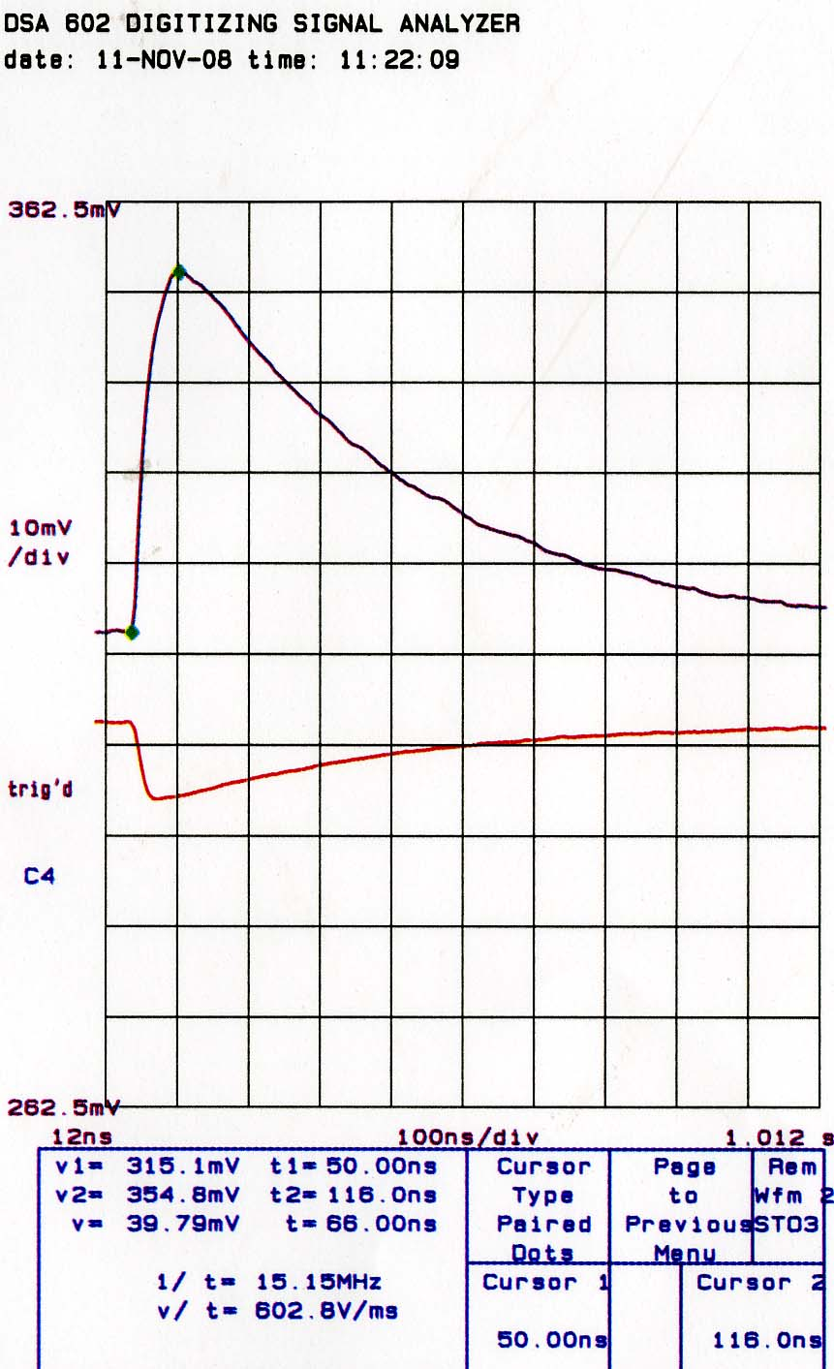
Shaper Output
Integrator Output

Figure1. Integrator and shaper buffered outputs for Qin = 0.5 fC, Cin = 1.90 pF, all settings at default (except for BW = 0). Measured gain = 79 mV/fC.

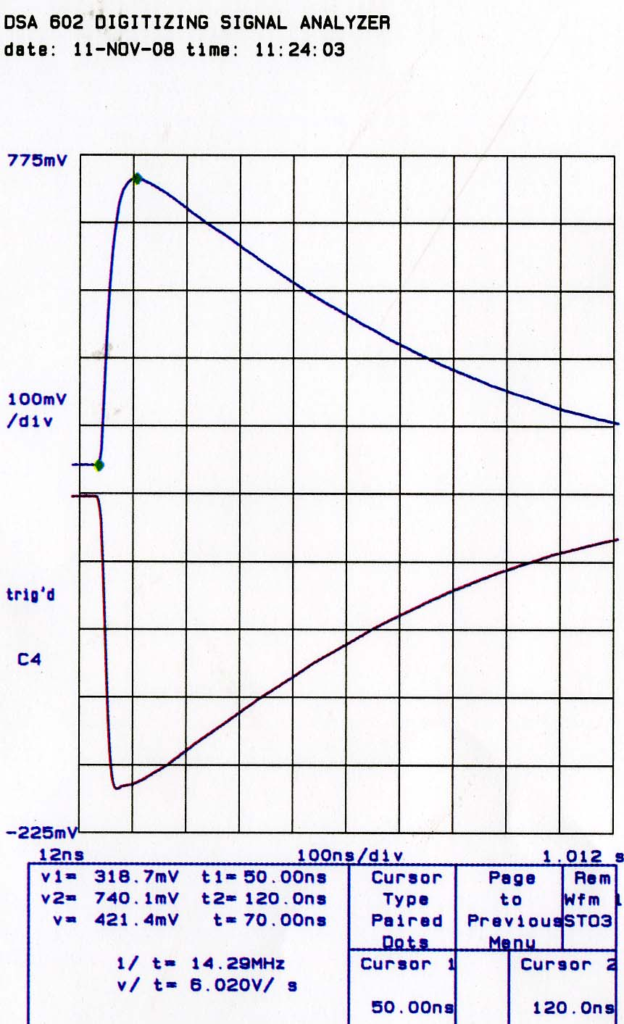

Figure 2. Qin = 2.0 fC. Figure 3. Qin = 5.0 fC

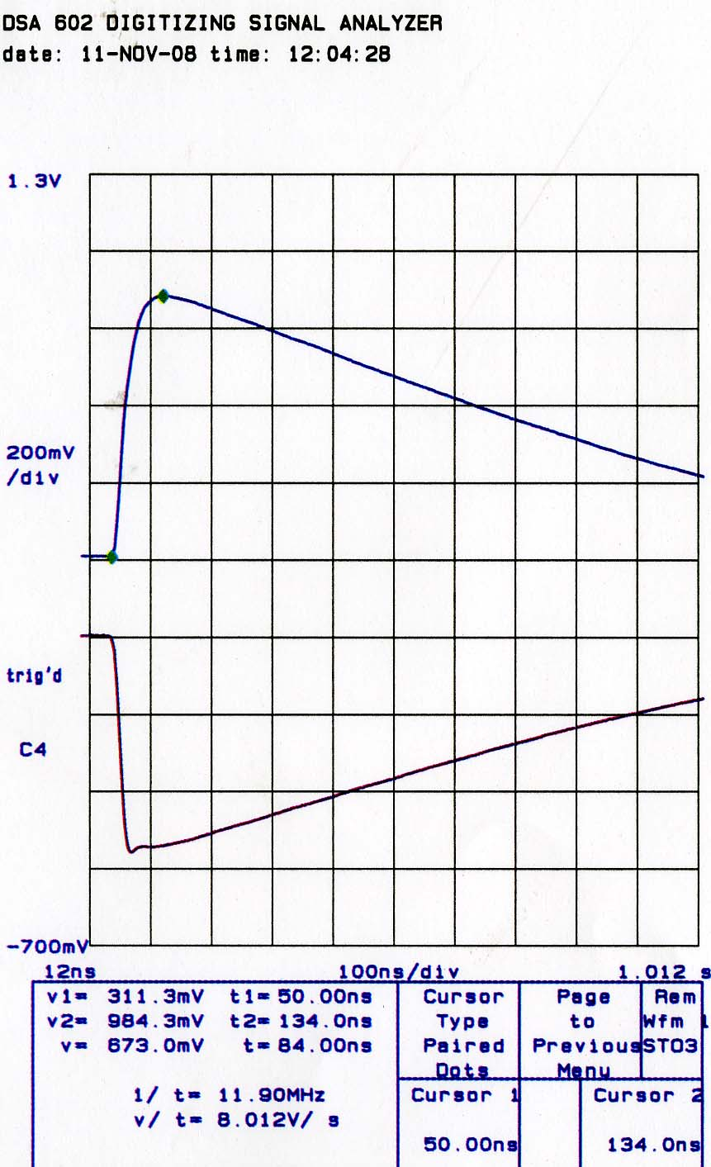

Figure 4. Qin = 8.0 fC.

As the input pulse magnitude increases from 0.5 fC to 8.0 fC, the shaper output peaking time changes from 66 ns to 84 ns. This is predicted by simulation, and is due to the fact that for small signals, the integrator feedback acts like a resistor (which results in an RC decay), and for large signals, the integrator feedback acts like a constant current (which gives a constant and proportionally slower decay rate).

The response of the FPHX over its full dynamic range was measured by stepping the threshold setting (the DAC for comparator 0) and finding the input charge necessary to flip comparator 0. The result is shown in Figure 5. The response is fairly linear, except for the fact that the slope changes somewhat at around 1.5 fC. This can be seen Figure 6. The error from the linear fit over the whole range is shown in Figure 7. A linear fit for just the lower end of the range (< 1 fC) is done in Figure 8, showing the different slope. Note that this test was done with a single comparator, so there is no comparator dispersion effect present. Dispersion from multiple comparators will add random offsets.

Figure 5. FPHX amplitude response over full dynamic range

Figure 6. FPHX amplitude response zoomed in to < 2 fC

Figure 7. FPHX deviation from linear fit over whole range

Figure 8. FPHX linear fit for Qin < 1 fC
Noise
\During testing, it was noticed that the FPHX integrator is prone to low-level oscillation at about 25 MHz, depending on the programmable settings. This oscillation can only be confirmed by looking at the Channel 0 integrator buffer output, since it can be at a relatively low level and may not result in obviously pathological chip behavior. This oscillation is undoubtedly due to the fact that on the test bench, none of the channels (except for Ch. 0) are connected to an input capacitance. If all channels are loaded (by connecting to a detector, for example), then this oscillation should disappear. However, this should be thoroughly checked. No further prototype submissions should occur until multiple chips have been connected to detectors on one test board and it is confirmed that no oscillation is present.

The channel-to-channel dispersion in threshold setting is seen to be around several mV, which is equivalent to several hundred electrons (rms). This is probably too big if the threshold is set at around 2000 electrons (some channels with the larger offsets will fire randomly). Either the threshold must be set higher (say 4000 electrons), or the design must be modified to reduce the dispersion. It is possible to consider reducing the threshold dispersion by moving some transistors closer together and increasing the transistor sizes. This is recommended for the next submission.

The noise was measured on channels 0 – 14 to look at the effect of different input transistor sizes. Unfortunately, it was discovered afterward that low-level oscillation was probably present for some of the measurements. Even so, the pattern is fairly clear and the input transistor choice obvious. The noise intercept measurement is done with the channel wire bond removed. The lowest noise for a discrete added input capacitance of 1.90 pF plus wirebond capacitance of approximately 0.3 pF is around 300 electrons. This is obtained with an input W/L of 222/0.6 or 168/0.6, under the condition of no oscillation. The 112/0.6 input transistor results may have been somewhat contaminated by oscillation, but in any case gives higher noise than channels 0 and 2. The channel 0 (W/L = 168/0.6) noise slope was initially measured at 64 e/pF, but this measurement was found to be done with low-level oscillation present. Without oscillation, it was measured at 56 e/pF (this value shown in Table 1). Channels 0 and 2 give essentially identical noise results, so W/L = 222/0.6 is a good choice for input transistor dimension.

Table 1. Noise vs. input transistor W/L
Ch# | W/L | Noise slope (e) | Noise intercept (e)
0 | 168/0.6 | 56 | --
1 | 112/0.6 | 66 | 172
2 | 222/0.6 | 56 | 169
3 | 140/0.25 | 110 | 194
5 | 280/0.25 | 98 | 190
6 | 112/0.32 | 90 | 208
9 | 112/0.45 | 79 | 176
11 | 252/0.45 | 62 | 162
12 | 84/0.8 | 68 | 165
14 | 196/0.8 | 72 | 180
Noise vs. input transistor bias current setting

The noise was measured on Channel 0 (168/0.6) for different settings of P1Sel, which controls the DC bias current through the input transistor. The results are shown in Table 2. The discrete input capacitance (not including bondwire stray C) for this set of measurements was Cin = 1.9 pF, and all other settings were nominal, except for BW = 2.

Table 2. Noise vs. input transistor bias current
P1Sel | Bias (uA) | Noise (e)
000 | 10 | 366
001 | 14 | 323
101 | 30 | 294
111 | 38 | 287

The noise level is not very sensitive to bias current, therefore it may be desirable to trade power for noise. For example, P1Sel could be set to 010 or even 000 to reduce power. The BW parameter should then be set accordingly.

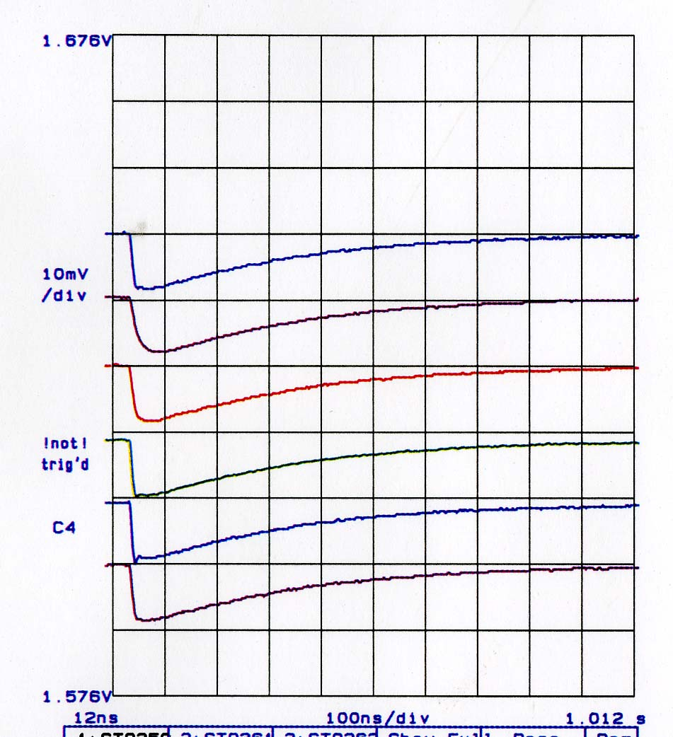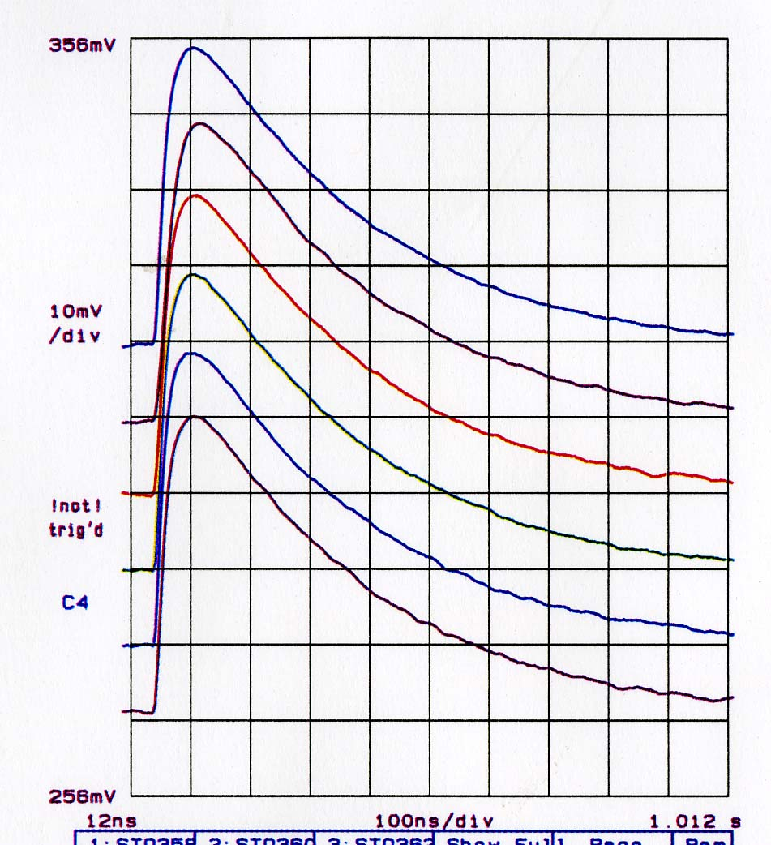
Integrator output
Shaper output
BW=2, P1Sel=5
BW=2, P1Sel=0
BW=2, P1Sel=2
BW=2, P1Sel=7
BW=0, P1Sel=2
BW=0, P1Sel=0

Figure 9. Integrator and shaper out for different settings of BW and P1Sel (Cin=1.90pF)

Comparator output histograms

A number of histograms of the Ch. 0 buffered comparator output are shown in Figures 9 and 10. For a given input capacitance, histograms are taken for three different input charge magnitudes, representing three points on the S-curve: 88%, 50%, and 12%. The histograms show the average delay and comparator pulse width (for nominal settings) and the effect of noise.

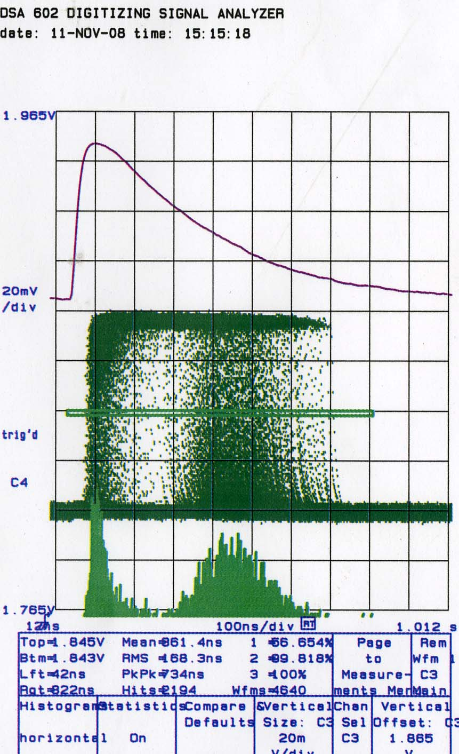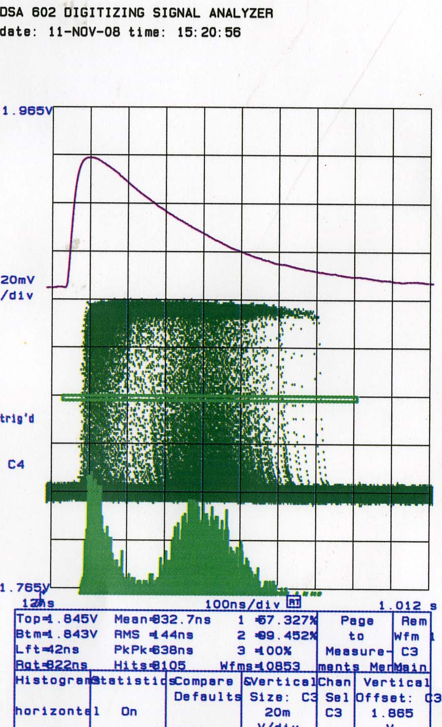
Buffered shaper output (averaged)
Buffered
comparator output

Comparator triggered 88% of the time
Comparator triggered 50% of the time
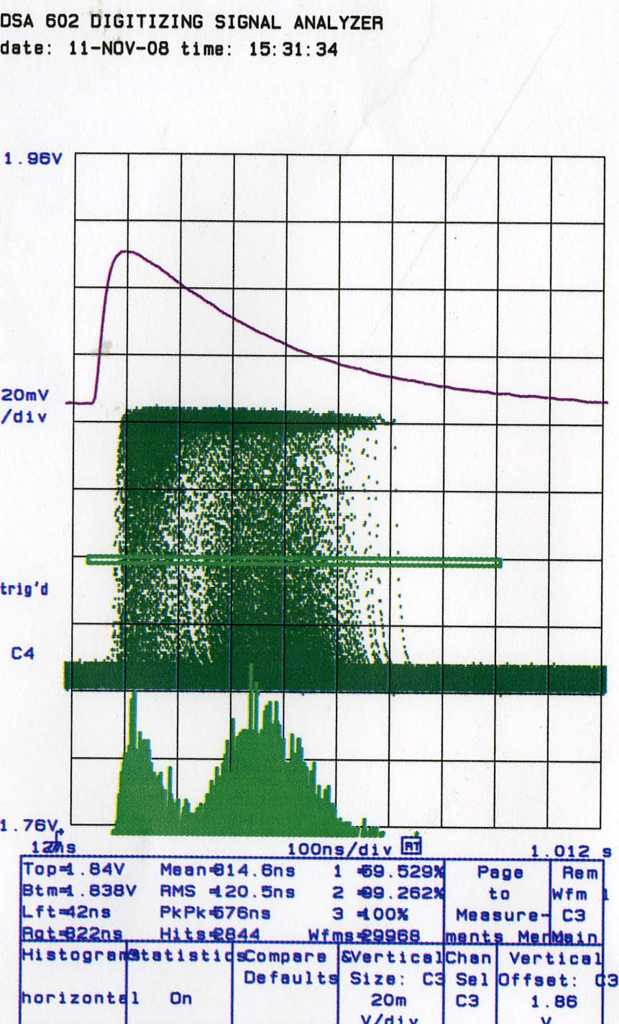
Figure 10. Comparator 0 histograms

Channel 0, Cin = 1.90 pF
Threshold DAC setting = 11
Input pulse adjusted to 3 different values on “S” curve
(88%, 50%, 12%)

Comparator triggered 12% of the time
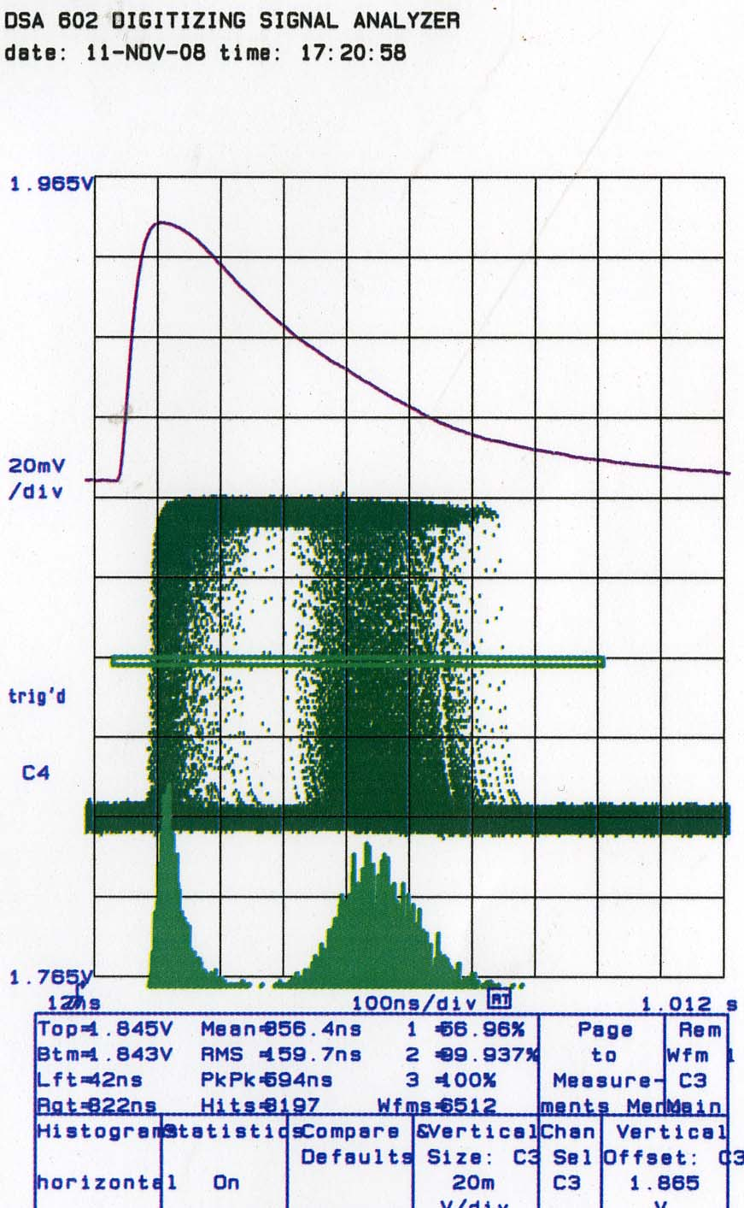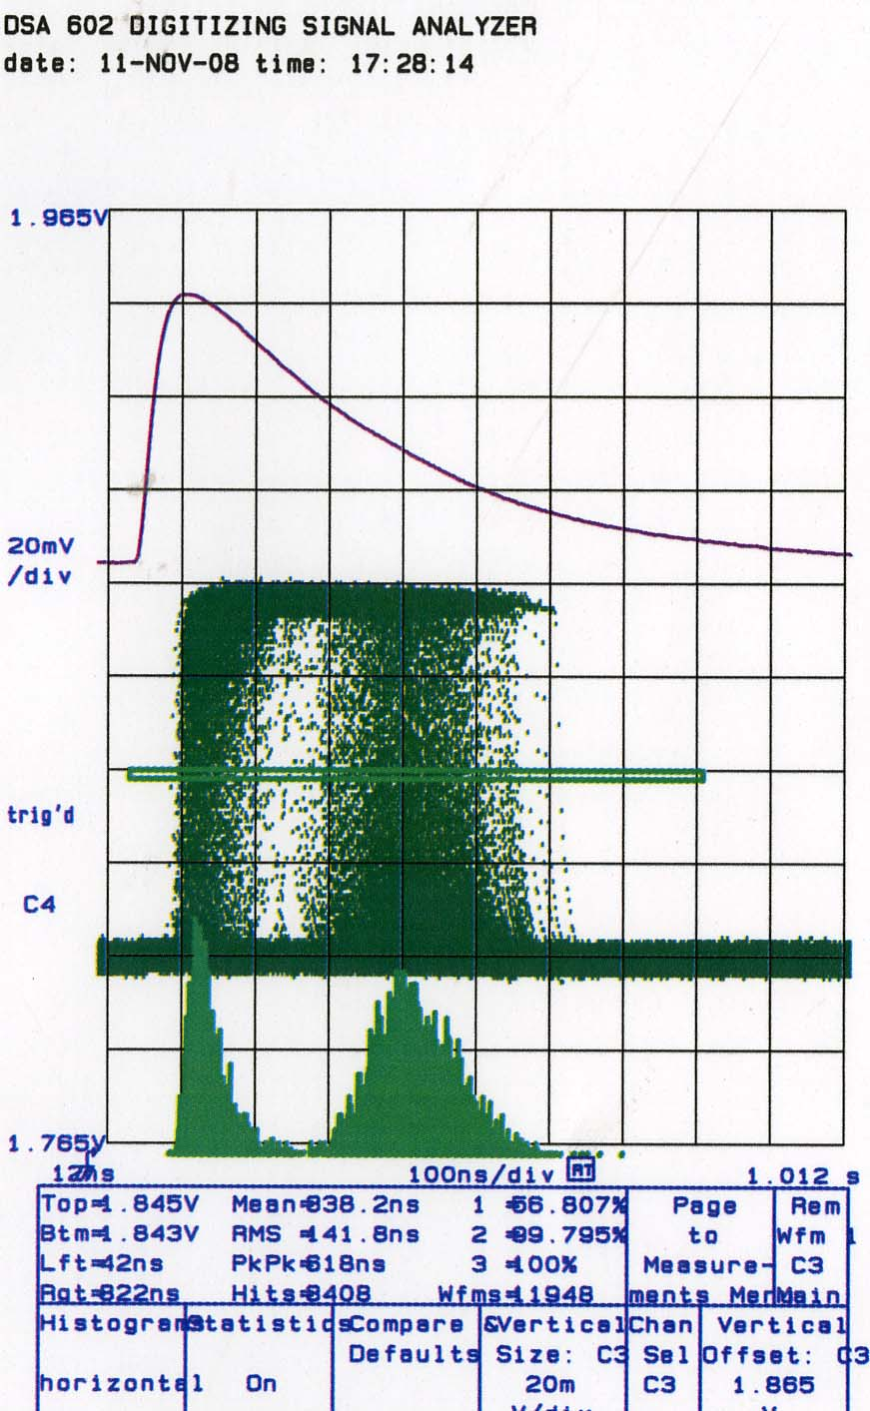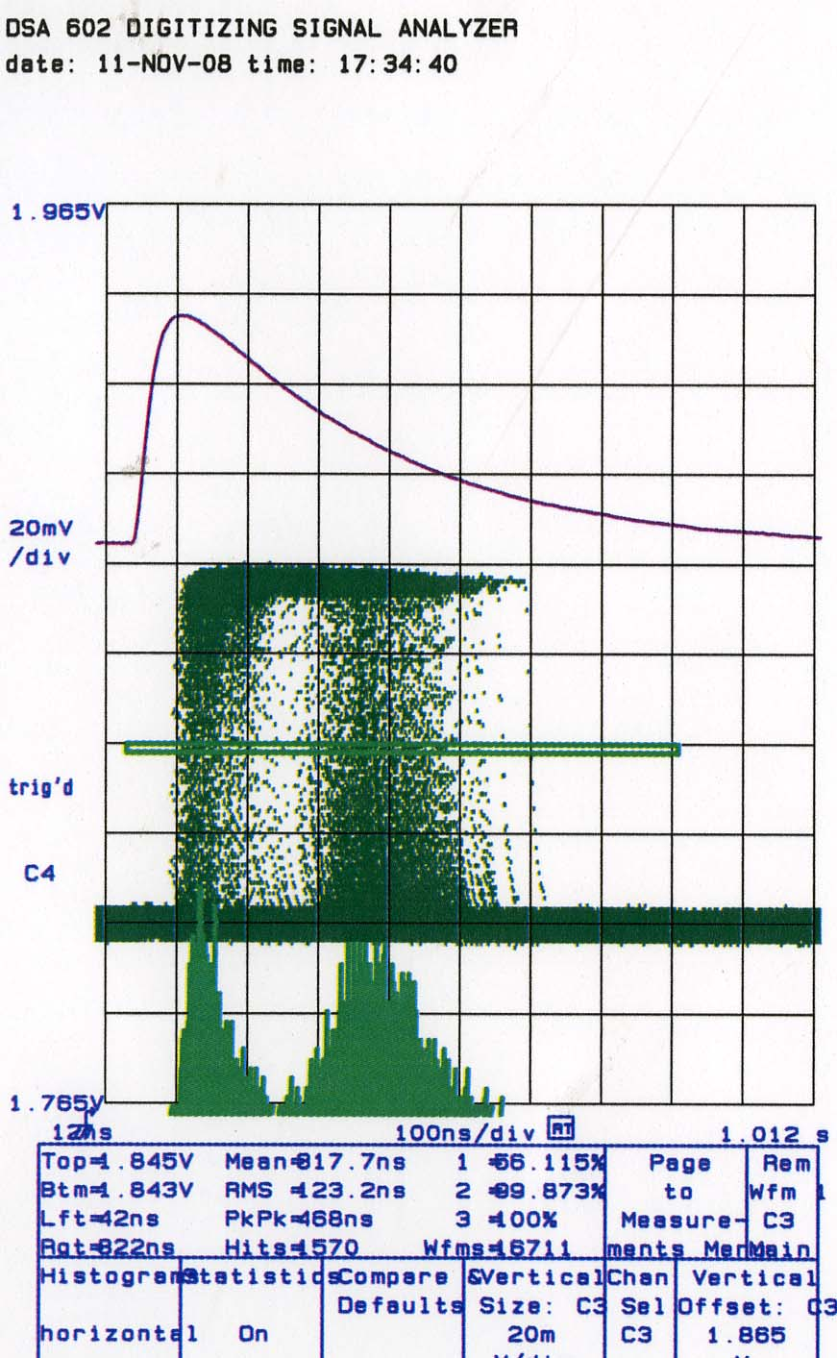
Figure 11. Comparator 0 histograms

Channel 0, Cin = 0.95 pF
Threshold DAC setting = 11
Input pulse adjusted to 3 different values on “S” curve
(88%, 50%, 12%)

Comparator triggered 88% of the time
Comparator triggered 50% of the time
Comparator triggered 12% of the time
Test pulse

One source of confusion about the digital test pulse is that it is triggered by a high-to-low transition on the inject input line, not low-to-high. If low-to-high is desired, it would be a trivial change in the next prototype submission.

The analog test pulse was used for all bench tests. The inject capacitor is very close to nominal (25 fF). There is a small parasitic from the test pulse input to all channels (fraction of a fF), so that even if a channel is masked off, it still receives a small charge injection (on order of 1% of the magnitude it would get if it were not masked).

There is almost no crosstalk between neighbor channels. If a large test pulse is given to one channel, its immediate neighbor sees no more than a channel located at the opposite end of the chip.

The output pulse shape is somewhat dependent on the number of channels receiving the test pulse. See Figure 12. Adding a bypass capacitor to the BIAS pin has little effect. However, this problem seems small enough to be buried in the noise.

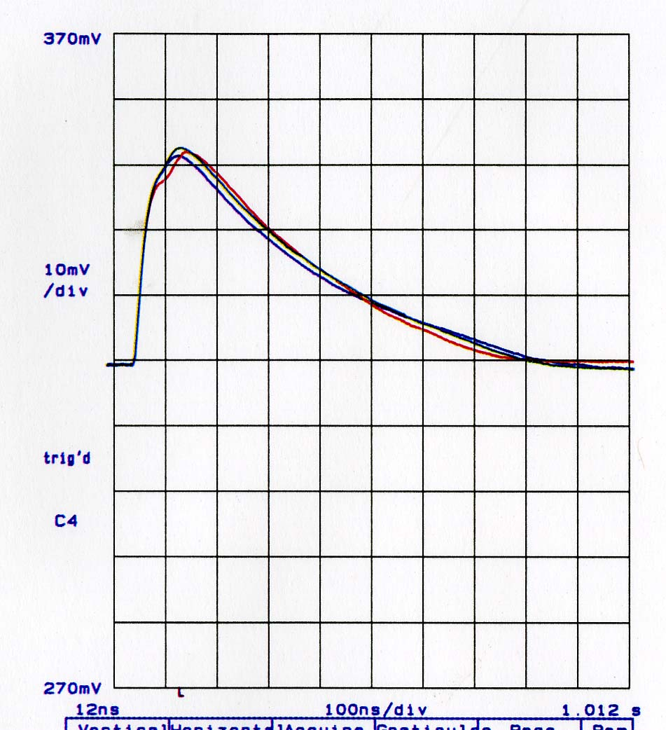
Figure 12.
Ch. 0 shaper output with test pulse input

Blue: test pulse to Ch. 0 only
Green: test pulse to Ch. 0-9
Red: test pulse to Ch. 0-127

Comparator speed

The comparator speed can be adjusted with two programmable parameters, P2Sel (mainly rising edge delay) and P3Sel (mainly falling edge delay). The following comparator histograms in Figure 13 illustrate the effect of these parameters. In all cases, the input signal magnitude is adjusted so that the comparator trips 50% of the time. The resultant leading-edge delay and pulse width measurements (average) are given. Faster comparator speed results in slightly higher noise, but less than a 10% increase worst case.
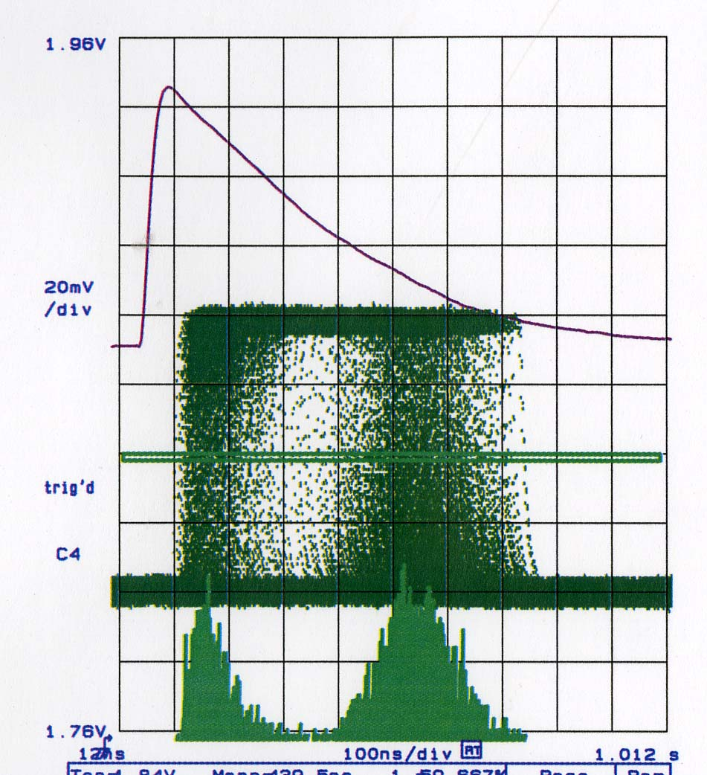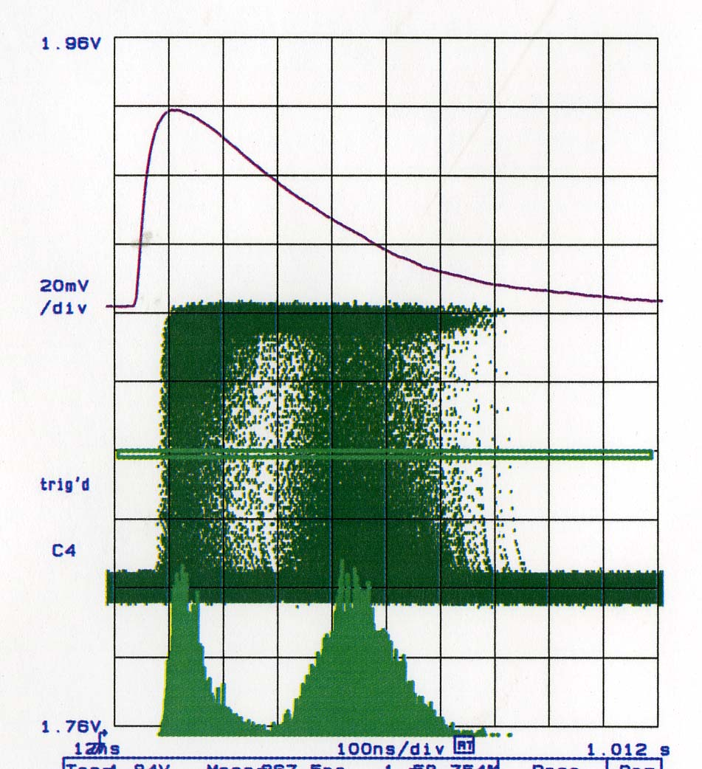
Shaper
output
Comparator output
Qin = 0.48 fC
P2Sel = 0000
P3Sel = 00
Qin = 0.40 fC
P2Sel = 0100
P3Sel = 00
(default)
Comp. delay = 120ns, width = 380ns
Comp. delay = 80ns, width = 320ns

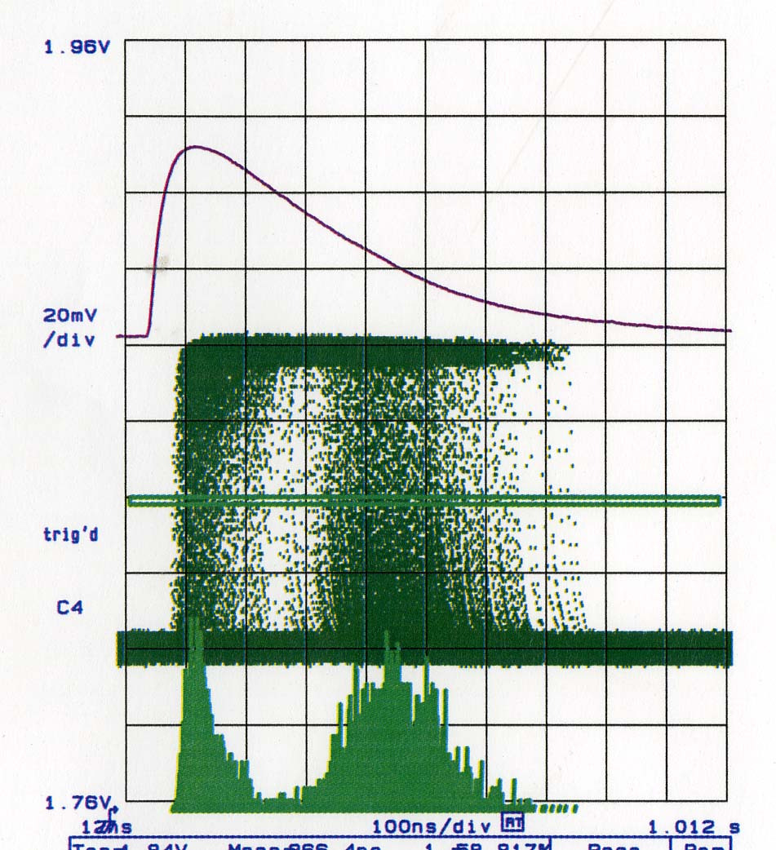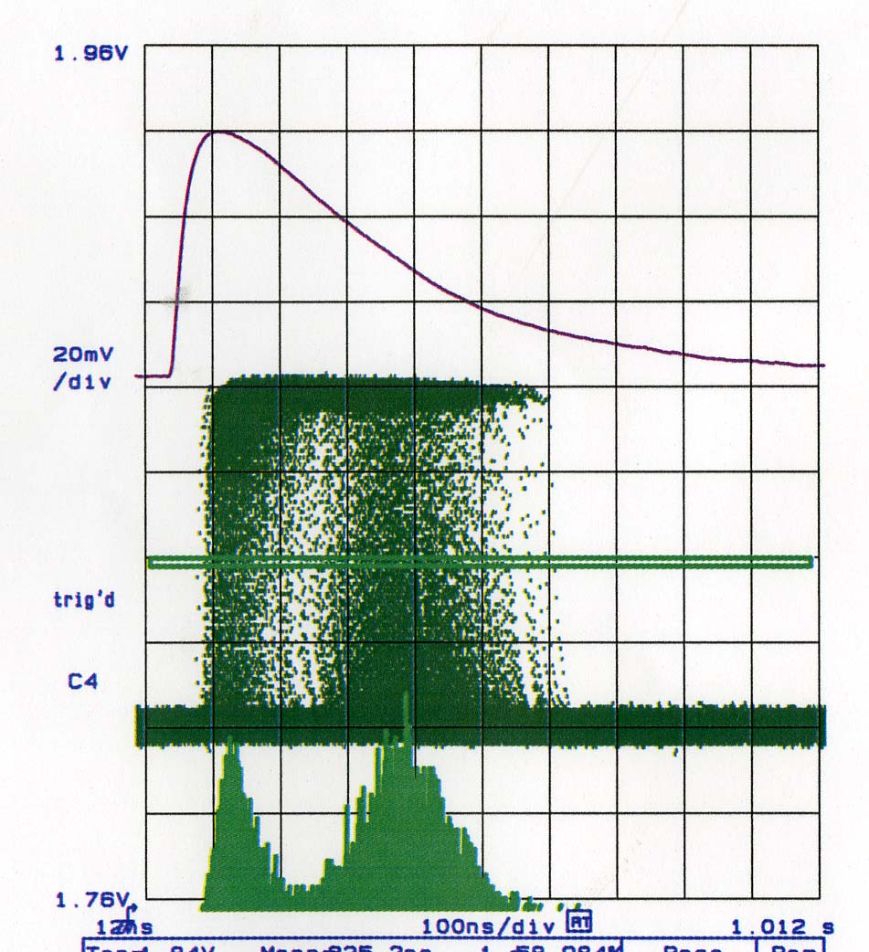
Qin = 0.38 fC
P2Sel = 1111
P3Sel = 11

Qin = 0.41 fC
P2Sel = 0100
P3Sel = 11

Comp. delay = 75ns, width = 325ns
Comp. delay = 85ns, width = 255ns

Figure 13.

