FPHX QA and Testing
July 29, 2008

The design layout of the FPHX chip was qualified using software tools that verify correct process and performance design criteria. Simulations were performed to model various input data patterns to evaluate performance of the chip. Before the design was released to the foundry, there was a series of design reviews. The review participants included the FNAL design team, Eric Mannel and Cheng-Yi Chi of Columbia-Nevis, and appropriate representation from the FVTX collaboration, including the Project Leader, the Deputy Project Leader and the Subsystem Manager.

FVTX personnel, led by Jon Kapustinsky, LANL, and David Winter, Columbia-Nevis, will participate in all aspects of the prototype die testing at FNAL. The prototype die will be extensively tested in the lab using analog test boards, wire bonding the appropriate signals from the die to readout pads on the test board. In addition to the function pads that are required to operate the chip, there are a number of test pads (Figure 1) that can be wire bonded to a test board.

Front-end related chip pins

- Analog Ground
  - ground return dedicated to input transistor source only. Bond directly to hybrid ground plane.
- Analog Ground 2
  - ground for integrators, shapers, and analog portion of comparators. Bond directly to hybrid ground plane.
- Analog Power
  - 2.5V analog supply for integrators, shapers, and analog portion of comparators. Bypass directly to ground.
- Substrate
  - separate net for substrate connection only. Bond directly to hybrid ground plane.
- Iset
  - Master current reference to set Front-end bias levels. Nominally set to 30 uA (40K resistor to ground).
- injInputAnalog
  - A positive going transition from an analog level V1 to level V2 will inject a charge of (V2 – V1)(25 fF) into all channels that are enabled for charge injection. Level V1 should be close or equal to ground.
- injInputDigital
  - a negative going digital transition on this input will inject a programmed charge into all channels that are enabled for charge injection. The magnitude of the charge is set with a DAC.
- Reset, Resetb
  - This is a Back-end LVDS input, whose internal CMOS version is also used by the Front-end to reset all the comparators.
- Digital Ground and Digital Power
  - These are Back-end supply pads which are also used by the Front-end to power the digital portion of the comparators

Bondable Test Pads

A series of bondable test pads in the interior of the chip are provided on the prototype chip, in order to be able to view buffered versions of certain analog and digital signals. Some or none of these may be included on the production version of the chip. See Figure 1 for the location and function of these pads.

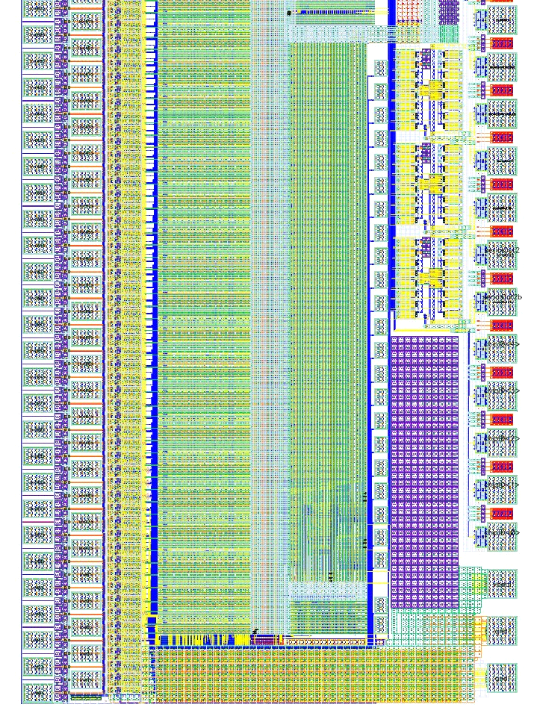
Bondable Test Pads
(prototype chip only)
Ch. 0 Integrator
buffered output, bias with 39K to +20V
Ch. 0 Shaper
buffered output, bias with 51K to
-
10V
Ch. 0 Comparator0 buffered output, bias with 51K to ground
Ch. 0 Comparator1 ...
Ch. 0 Comparator2
…
Ch. 0 Comparator3
…
Ch. 0 Comparator4
…
Ch. 0 Comparator5
…
Ch. 0 Comparator6
…
Ch. 0 Comparator7
…
Ch. 1 Comparator0
…
Ch. 2 Comparator0
…
Ch. 3 Comparator0
…
Ch. 4 Comparator0
…
Ch. 5 Comparator0
…
Ch. 6 Comparator0
…
Ch. 7 Comparator0
…
Ch. 8 Comparator0
…
Ch. 9 Comparator0
…
Ch. 10 Comparator0
…
Ch. 11 Comparator0
…
Ch. 12 Comparator0
…
Ch. 13 Comparator0
…
Ch. 14 Comparator0 buffered output, bias with 51K to ground
(Bottom of FPHX chip)
Figure 1.

Several analog probe pads have also been included on the prototype die to provide additional test points.

Diagnostic probe pads (5u X 5u, prototype chip only)

A collection of small probe pads, which are suitable for probing with a picoprobe on a probe station, are added to certain internal signals on the prototype chip. These can aid in troubleshooting in the event of a problem or malfunction. Most likely these pads will not exist on a production chip. Following are the signals with small probe pads:

- HitOr
- asyncReset
- slowControlIn
- BCOclk (same as SlowControlClock)
- serialClk
- SerialOut1, SerialOut2 (CMOS versions feeding LVDS drivers)
- chanInjEn<127>
- ThDAC7<1>, ThDAC7<7>
- Bandgap out
- Vref, Vth0-7
- All 8 comparator outputs on channels 15-17
- VdProt (positive protection diode reference)
- Internal digital inject pulse
- NBias1,2
- PBias 2,3,4
- FbBias1,2
- LeakBias
- P1Sel<2>

All the analog and digital functions of the die will be exercised. The testing of the die requires an additional interface board that will be used to communicate the slow controls functions between the test board and the DAQ test stand. The initial tests of the front-end will require extensive mapping of the parameter space that is provided via the programmable front-end bits. These bits are used to set a variety of bias currents, reference voltages and resistance and capacitance parameters in order to optimize gain, noise and time response of the front-end, especially the integrator and shaper output, and the comparator response. The primary front-end specifications that will be tested against acceptance criteria include:

- Detector leakage current compensation: programmable maximum of 0 – 50nA
- Effective Channel gain: 50, 67, 100, or 200 mV/fC (programmable)
- Output: 3-bit digital code per channel (digitized shaper output pulse height). No analog output.
- Output pulse dynamic range (shaper output): >800mV (25ke to 100ke, depending on the gain setting)
- Nominal output pulse peaking time: 60 ns (programmable, set by the shaper)
- Output pulse fall time: programmable, set by the integrator fall time adjust
- Noise at shaper output: (approximate from simulations)
- At max. input transistor bias of 38uA: 115e + 134e/pF (linear for total Cin>=2pF, including chip parasitics of approx. 0.5pF)
- At input transistor bias of 14uA: 110e + 196e/pF
- Power: Approx. 140 uW per channel for the maximum input transistor bias current of 38uA, 70 uW per channel for minimum input transistor bias current of 10uA.
- 2 test pulse inputs: one direct analog, one controlled by a DAC and digital input.

A description of the program bits and a suggested setup exercise follows below.

Front-end Program Bits

- P1Sel<2:0>: sets input transistor bias current = 10uA + [(4uA)(P1Sel)]. Default = 101. Higher bias current gives lower noise.
- Fb1Sel<3:0>: sets integrator feedback transistor bias current Ifb = 1.67nA + [(1.67nA)(Fb1Sel)]. Default = 0100. This current defines the equivalent feedback resistance (Rfb ~ 0.05/Ifb), which determines the output pulse fall time (in conjunction with the programmable integrator feedback capacitor Cfb, yielding time constant RfbCfb).
- N1Sel<3:0>: Integrator source follower bias = 1.25uA + [(0.625uA)(N1Sel)]. Default = 0110.
- LeakSel<3:0>: maximum DC input leakage current compensation = [1.6(Ifb) + (3.33nA)(LeakSel)]. Default = 0000.
- GSel<1:0>: determines integrator feedback capacitance Cfb = 25fF + [(25fF)(GSel)]. Default = 01. With a fixed shaper gain of about 5, the nominal system transfer gain can then be set to approximately 50, 67, 100, or 200 mV/fC.
- BWSel<4:0>: adds capacitance to the dominant node of the integrator. Explicit added capacitance = 10fF + [6fF(BWSel)]. Default = 00100. Used to compensate for the effects of varying input capacitance and gain setting on the integrator response.
- N2Sel<3:0>: Shaper bias current = 1uA + [(0.5uA)(N2Sel)]. Default = 0100. This is used to set the bandwidth of the shaper, which determines the output pulse rise time (peaking time). A shaper bias of 3.5uA results in a peaking time of approximately 60ns. Higher settings result in faster peaking times.
- P2Sel<3:0>: Comparator bias current = 0.5uA + [(0.25uA)(P2Sel)]. Default = 0100. Higher settings reduce comparator delay.
- P3Sel<1:0>: Comparator second stage pullup bias current. Default = 00. Mainly affects comparator trailing edge delay – higher settings reduce the delay.
- InjSel<2:0>: Digital inject circuit DAC setting. Charge inject magnitude = (1Ke)(InjSel + 1). Default = 000 (1Ke).
- Vref<1:0>: Shaper DC reference voltage = 150mV + [(60mV)(Vref<1:0>)]. Default = 01. For maximum dynamic range, set Vref as low as possible while still maintaining linearity.
- Vth0<7:0> (Threshold ADC 0): 0th ADC comparator (discriminator) threshold = Vref + [(4mV)(Vth0)]. Default Vth0<7:0> = 00001000 (Vref + 32 mV).
- Vth1<7:0>: 1st ADC comparator threshold = Vref + [(4mV)(Vth1)]. Default Vth1<7:0> = 00010000 (Vref + 64 mV).
- Vth2<7:0>: 2nd ADC comparator threshold = Vref + [(4mV)(Vth2)]. Default Vth2<7:0> = 00100000 (Vref + 128 mV).
- Vth3<7:0>: 3rd ADC comparator threshold = Vref + [(4mV)(Vth3)]. Default Vth3<7:0> = 00110000 (Vref + 192 mV).
- Vth4<7:0>: 4th ADC comparator threshold = Vref + [(4mV)(Vth4)]. Default Vth4<7:0> = 01010000 (Vref + 320 mV).
- Vth5<7:0>: 5th ADC comparator threshold = Vref + [(4mV)(Vth5)]. Default Vth5<7:0> = 01110000 (Vref + 448 mV).
- Vth6<7:0>: 6th ADC comparator threshold = Vref + [(4mV)(Vth6)]. Default Vth6<7:0> = 10010000 (Vref + 576 mV).
- Vth7<7:0>: 7th ADC comparator threshold = Vref + [(4mV)(Vth7)]. Default Vth7<7:0> = 10110000 (Vref + 704 mV).
- Inj_en: Enable charge injection feature (all channels). Default = 0 (off).
- Mask<127:0>: Mask bits to disable charge injection on a per-channel basis. Default = 0 (all off).

Programming Strategy

- First determine GSel based on the desired approximate transfer gain (50 – 200 mV/fC).
- Then depending on the value of the input capacitance (Cin), program BWSel to achieve fast integrator response without ringing.
- For Cin = 2 pF (1.5 pF detector + 0.5 pF parasitic):
  - If GSel = 00, set BWSel = 00000
  - If GSel = 01, set BWSel = 00100
  - If GSel = 10, set BWSel = 01000
  - If GSel = 11, set BWSel = 01100
- For Cin = 1.5 pF (1 pF detector + 0.5 pF parasitic):
  - If GSel = 00, set BWSel = 00001
  - If GSel = 01, set BWSel = 00110
  - If GSel = 10, set BWSel = 01010
  - If GSel = 11, set BWSel = 01110
- For Cin = 1 pF (0.5 pF detector + 0.5 pF parasitic):
  - If GSel = 00, set BWSel = 00010
  - If GSel = 01, set BWSel = 01000
  - If GSel = 10, set BWSel = 01110
  - If GSel = 11, set BWSel = 10101

- Program Fb1Sel based on the desired fall time constant
- Then program N2Sel to achieve the desired rise time/peaking time (rise and fall times will have some effect on the transfer gain)
- Program Vref to the lowest value possible that allows linear response (nominally 00)
- Based on the transfer gain, set the desired comparator thresholds

The primary back-end functions to be tested for acceptable operation include:

- Core
  - Test readout at full speed
  - Clock operations: interference, noise, phasing sensitivity
  - Pulse inject response (analog and digital pulse inject)
  - Threshold scan
  - Mask pattern tests
  - Successive beam clock hit response
  - Power consumption under different setup configurations

- Serial controller
  - Read/write registers
  - Resets
  - Mask bits
  - Wild card function
  - Serial data output, one and two channel operation

- FIFO
  - pointer operation
  - FIFO full response

Lab bench tests will be carried out in parallel at FNAL, UNM and Nevis Labs using a common test stand design, which is under development at LANL. If design problems are identified in the FPHX, there is schedule contingency allowance for a design correction, and a second prototype submission to MOSIS, and a subsequent round of testing. In total, eight months have been scheduled for all FPHX prototyping and testing. Prior to submitting the engineering run for production quantities, the review team will assess the status of the QA and testing.

The engineering run submission will be made to TSMC on a 0.25μm process line. The wafers will be probe station tested at FNAL with the participation of FVTX personnel. The majority of QA testing for production lots will be done on a probe station by measuring reference parameters and as many key performance metrics as is practical. The suite of tests that will be incorporated into the FPHX-specific probe station software will be developed in collaboration with William Wester of FNAL. Wester is an expert in probe station testing, and he will help us determine the proper balance between comprehensive probe testing and practical implementation.

Assuming an historical average 80% yield, the total number of production wafers needed is 15, which represents 1 ½ submissions (1088 die per wafer). The minimum follow-on submission is ½ lot. If the production yield is 90%, we will only need 10 wafers. A total of 3 months is scheduled for production QA.

Facilities and Manpower

FNAL has automated probe stations equipped with electronic characterization equipment. The ASIC Development Department head, Ray Yarema, has agreed, in principle, that FNAL engineers and technicians will develop FVTX specific probe station software and hardware to QA the FPHX chip. A contract needs to be placed in order to turn the agreement into a firm commitment. In addition, Ray has agreed that FVTX personnel will be allowed to participate in all aspects of the QA at FNAL. An office and workstation is being set up in the electronics department to accommodate FVTX personnel for the QA.

There are test labs at UNM, LANL, Columbia-Nevis. FPHX die, especially at the prototype stage, will be distributed to these Labs for parallel evaluation.

The probe station at FNAL can be operated by a single well-trained student for the production run QA.

