Engineering Note
for
1M Hodoscope Assembly

TITLE: 1M Hodoscope Assembly

AUTHOR: Shaun Newman, P-21, Los Alamos National Laboratory

DATE: 3/2017

ABSTRACT: This document describes an aluminum framework designed to secure and install a hodoscope array in E906. Once assembled this framework will be attached to an I-beam and placed in the E906 beamline.

DESIGN:

The hodoscope arrays for the station 1M hodoscope will be assembled at LANL. Each array is composed of 50 scintillators held in an aluminum frame constructed from 1515 extrusions from 8020 Inc. The extrusions are secured to each other with 8020 fasteners and 5/16-18 screws (Fig. 1). Figure 2 shows the fully assembled hodoscope array.

For the 1M hodoscope assembly, four of these arrays will be placed in a square pattern to form a detector approximately 96” x 96” (Fig. 3). When placed into the beamline the scintillators will be oriented horizontally. The four arrays will be held together by 8020 4334 (Fig. 1) brackets and 5/16-18 fasteners. The hodoscope assembly will then be fastened to two aluminum I-beams (Fig. 1) by 8020 4334 brackets (Fig. 1) and 5/16-18 fasteners. These two I-beams will then be attached to a third horizontal I-beam by 8020 4338 brackets and 5/16-18 fasteners. This assembly will be placed in the E906 beamline and attached to existing I-beams and to the floor via 8020 4338 brackets (Fig. 1), 5/16-18 fasteners, and concrete/block screws. The final assembly for the E906 beamline is shown in Figure 4.

During assembly, the hodoscope arrays, 8020 extrusions, and I-beams will be laid out horizontally. After assembly the entire package shown in Figure 4 will be lifted and rotated to be installed vertically into the E906 beamline. Table 1 lists the mechanical properties of the extrusion and I beam used in this framework.

Part No. | Cross Section | Area (in²) | Material | lbs/in | Ix (in⁴) | Iy (in⁴)
8020-1515 | 1.5” x 1.5” | 1.152 | 6105-T5 | .112 | 0.255 | 0.255

- UTS = 38ksi minimum, Yield = 35ksi minimum, Emod = 10.2e6 psi

Part No. | Cross Section | Area (in²) | Material | lbs/in | Ix (in⁴) | Iy (in⁴)
AL I Beam | 4" x 3" x 0.17" x 0.29" | 2.38 | 6061-T6 | .233 | 6.566 | 1.306

- UTS = 42ksi minimum, Yield = 37ksi minimum, Emod = 10e6 psi

Table 1 – Mechanical Properties of 8020 Extrusions and AL I Beams in 1M Hodoscope Assembly

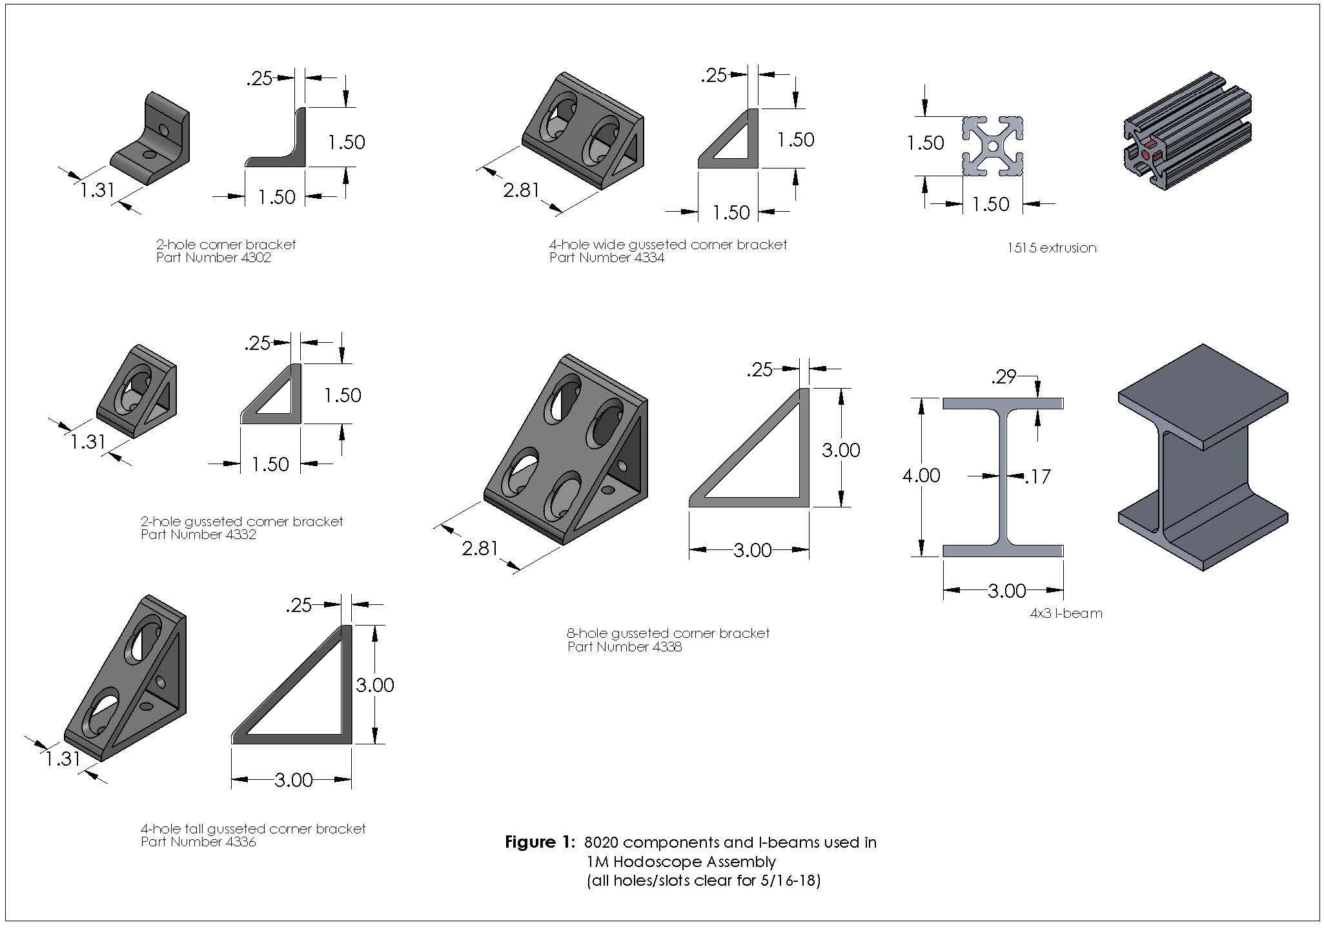

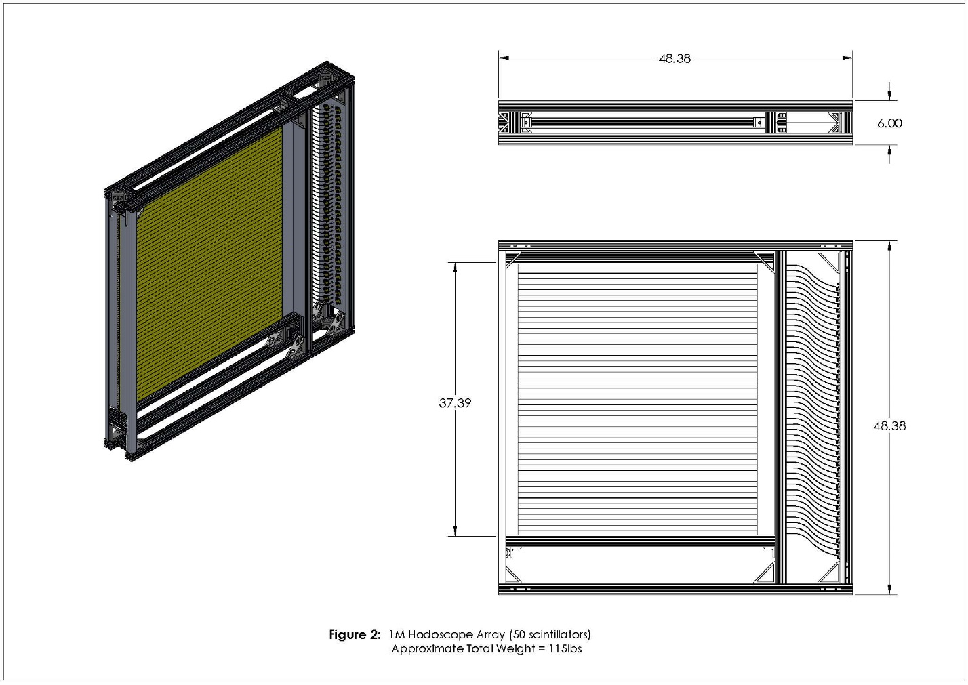
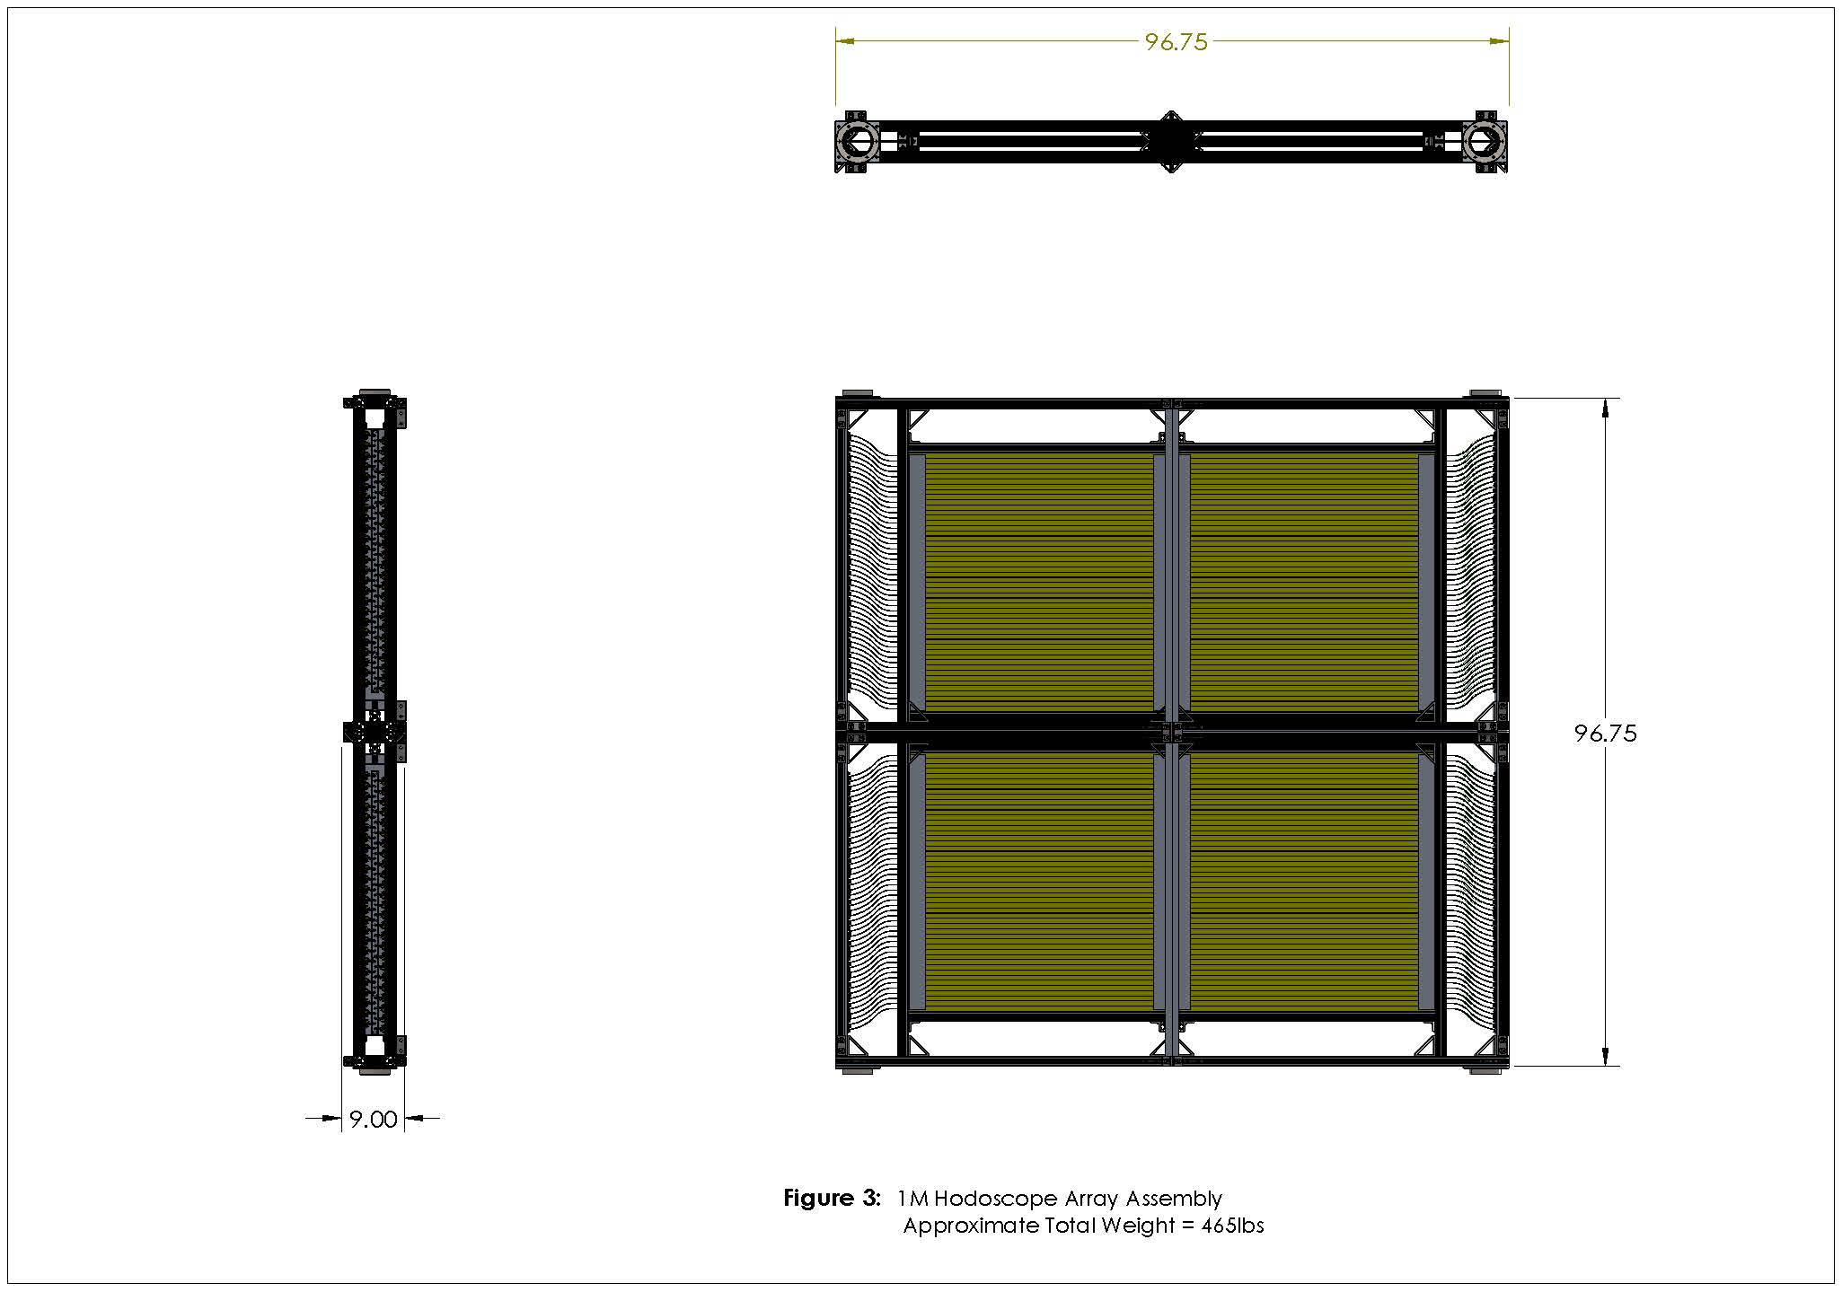
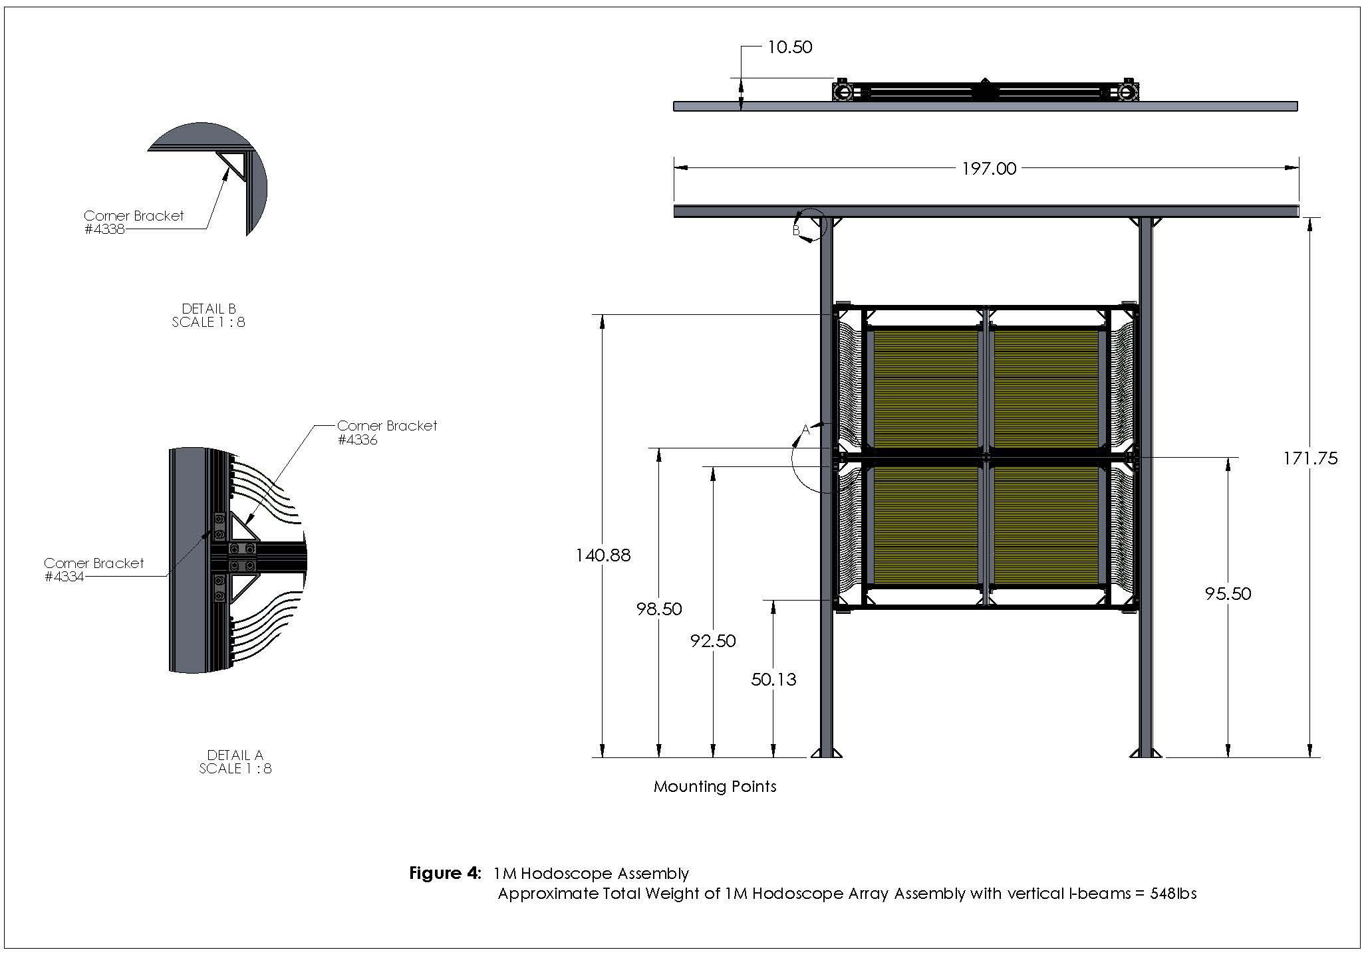

ANALYSIS:
The hodoscope array will be built horizontally and then lifted/rotated and installed vertically in the E906 beamline. This will be done by wrapping slings around top horizontal I-beam and using the crane in NM4. The assembly must be strong enough to withstand the rotation from horizontal to vertical.

Lifting/Rotating:
When the array assembly is horizontal it can be lifted at one end (by the I-beams and brackets) and re-oriented to the vertical. If each I-beam is treated as a beam supported on both ends, with load at 95.5” then the stress and deflection of each I-beam at the mounting points can be calculated using standard formulas (given cross section is constant):

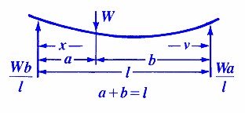

Stress between load and "a" load point (1):
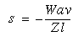
Stress between load and "b" load point (2):
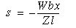
Deflection for location between load and "a" point (3):
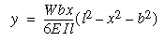
Deflection for location between load and "b" point (4):
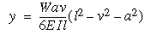

Where: W is the weight (274lbs (548/2))
l is the length (171.75 inches)
I is the moment of inertia, 6.566in⁴
Z is the section modulus (I/1.5in = 4.37in³)
E is the modulus of elasticity
x is some distance as indicated (95.5 inches)
y is some distance as indicated (76.25 inches)
a is some distance as indicated (¹140.88”, ²98.5”, ³92.5”, ⁴50.13”)
b is some distance as indicated (¹30.87”, ²73.25”, ³79.25”, ⁴121.62”)

Solving Equations (1) and (2) for each individual I-beam at the mounting points gives a maximum stress of 4276 psi at ⁴50.13 inches from the bottom of the I-beam. Bending stress of 4276 psi is acceptable for the 6061-T6 I-beams, the minimum yield strength of 6061-T6 is 37,000 psi.

Equations (3) and (4) for each individual I-beam at the mounting points gives a maximum deflection of 0.43 inches at a distance of ³92.5 inches from the bottom. This deflection occurs at the start of rotation and will fall to zero as the detector is made vertical and is acceptable.

Four 8020 4338 brackets are used to attach the vertical I-beams of the hodoscope assembly to an aluminum I-beam (4" x 3" x 0.17" x 0.29"). See Figure 1 and 4. Each bracket is attached to a vertical I-beam using four 5/16-18 bolts. They are also attached to the horizontal I-beam using four 5/16-18 bolts per bracket. At the start of rotation each 5/16-18 bolt (32 bolts total) will experience a shear of roughly 17.1-lbs (548/32) which will vanish as the array is rotated. With a minor diameter of 0.2443 and an area of 0.0520-in², the resulting shear stress in each 5/16-18 bolt is roughly 329psi.

Eight 8020 4334 brackets are used to attach the hodoscope array assembly to the vertical I-beams. See Figure 1 and 4. Each bracket is attached to a vertical I-beam using two 5/16-18 bolts. They are also attached to the 8020 frame using two 5/16-18 bolts per bracket. Each 5/16-18 bolt (32 bolts total) will experience a shear of roughly 15-lbs (465/32). With a minor diameter of 0.2443 and an area of 0.0520-in², the resulting shear stress in each 5/16-18 bolt is roughly 288psi.

Grade 5 screws with yield strength of 92ksi (per SAE J429) are readily available. Assuming that shear strength is 60% of yield strength, this results in shear strength of 55ksi which is far in excess of these expected actual values.

