1. Pixel sensor dimension

Table 1.1 Pixel sensor geomety
Size (z×φ) | 56,720 μm × 13,920 μm
Thickness | 200 μm
Active are (z×φ) ^{*1} | 55,600 μm × 12,800 μm
Edge dead space ^{*2} | 560 μm (z), 560 μm (φ)
Pixel pattern | Two patterns : basic pixel, junction pixel
Pixel pitch (z×φ) | Basic pixel : 425 μm × 50 μm, junction pixel : 625 μm × 50 μm,
Number of pixels (z×φ) | 4×32×256 = 32,768 (basic pixels : 122×256, junction pixels : 6×256)
Bonding pad size (z×φ) | 69 μm × 104 μm
Bonding pad pitch | 48 μm
Number of bonding pads | 128×12 = 1,536
Guard ring | 1 guard ring, GR width : 150 μm
*1 : Active area is defined by (number of pixels) × (pixel pitch) for each direction.
*2 : The guard ring is included.

Table 1.2 R/O chip geometry
Size (z×φ) | 13,646 μm × 15,536 μm
Thickness | 150 μm
Pixel pitch (z×φ) | 425 μm × 50 μm
Number of pixels (z×φ) | 32×256 = 8,192
Wire-bonding pad size (z×φ) | 96 μm × 101 μm
Wire-bonding pad pitch ^{*1} | 120 μm
Number of wire-bonding pads^{*1} | 103
*1 : Unused pads are not included.

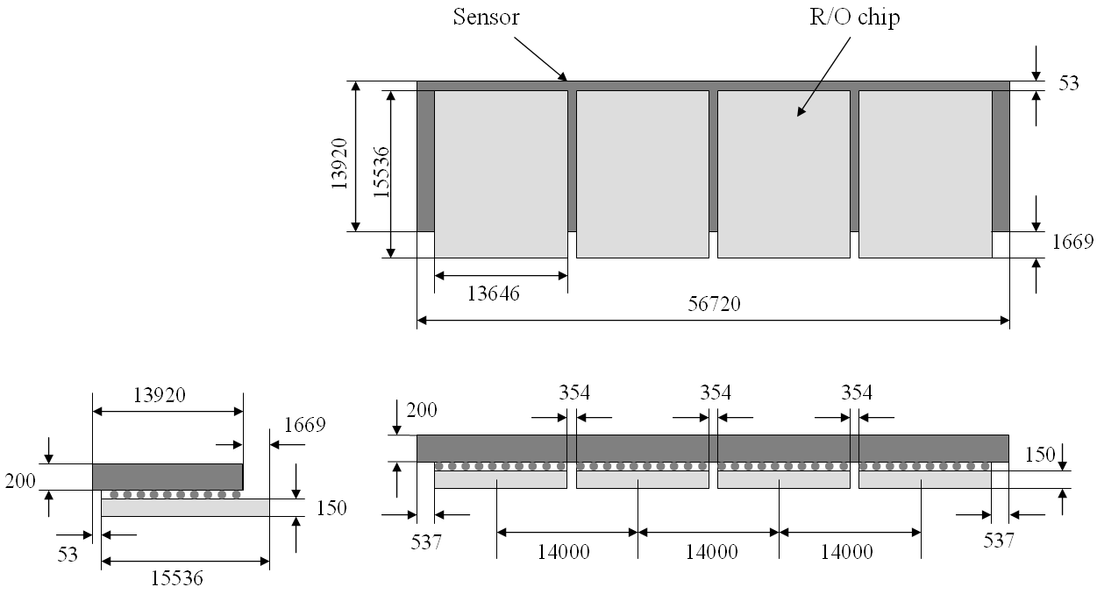
Figure 1.1 Bump-bonded pixel ladder (not to scale). Unit is in μm.

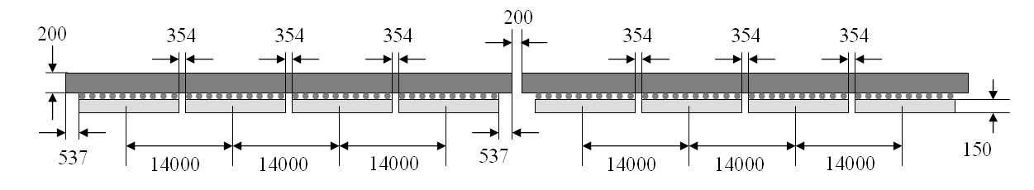
Figure 1.2 Relation between bump-bonded pixel ladders (not to scale). Unit is in μm.

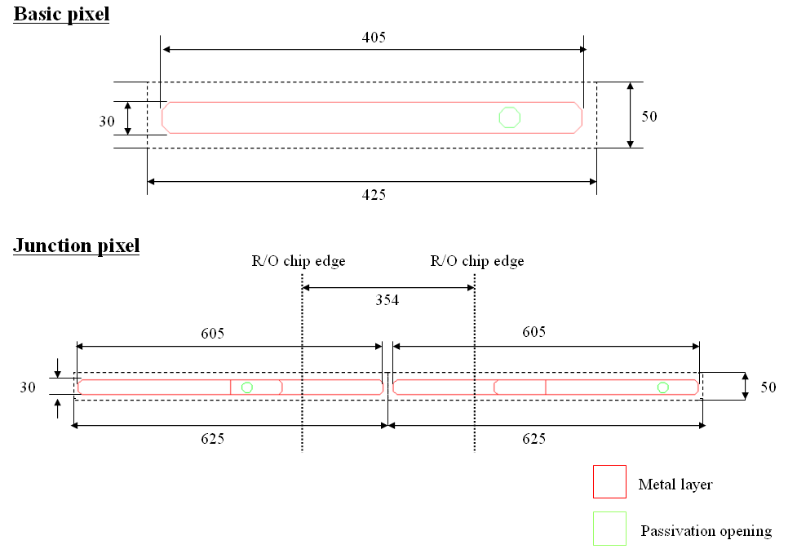
Figure 1.2 Pixel pattern. Unit is in μm.
2. Stripixel sensor dimension

Table 2.1 Stripixel sensor geometry
Size (z×φ) ^{*1} | 63,557(±20) μm × 34,913(±20) μm
Thickness | 625 or 500 μm
Active area (z×φ) ^{*2} | 60,000 μm × 30,720 μm
Edge dead space ^{*3} | 2,096.5 μm (φ), 1,778.5 μm (z)
Pixel pitch (z×φ) | 1,000 μm × 80 μm
Number of pixels (z×φ) | 60×384 = 23,040
Cell (electrode in pixel) | Spiral shape, 5 μm line / 3 μm space, 5 turns
Number of cells per strip | 30
Number of strips | 384×2 = 768 (x), 384×2 = 768 (u),
Bonding pad size (z×φ) | 69 μm × 104 μm
Bonding pad pitch | 48 μm
Number of bonding pads | 128×12 = 1,536
Guard ring | 2 guard rings, inner GR width : 308.5 μm, outer GR width: 100 μm
Guard ring pad size | 104 μm × 238 μm
*1 : Hamamatsu’s dicing accuracy is ±20 μm.
*2 : Active area is defined by (number of pixels) × (pixel pitch) for each direction.
*3 : Two guard rings are included.
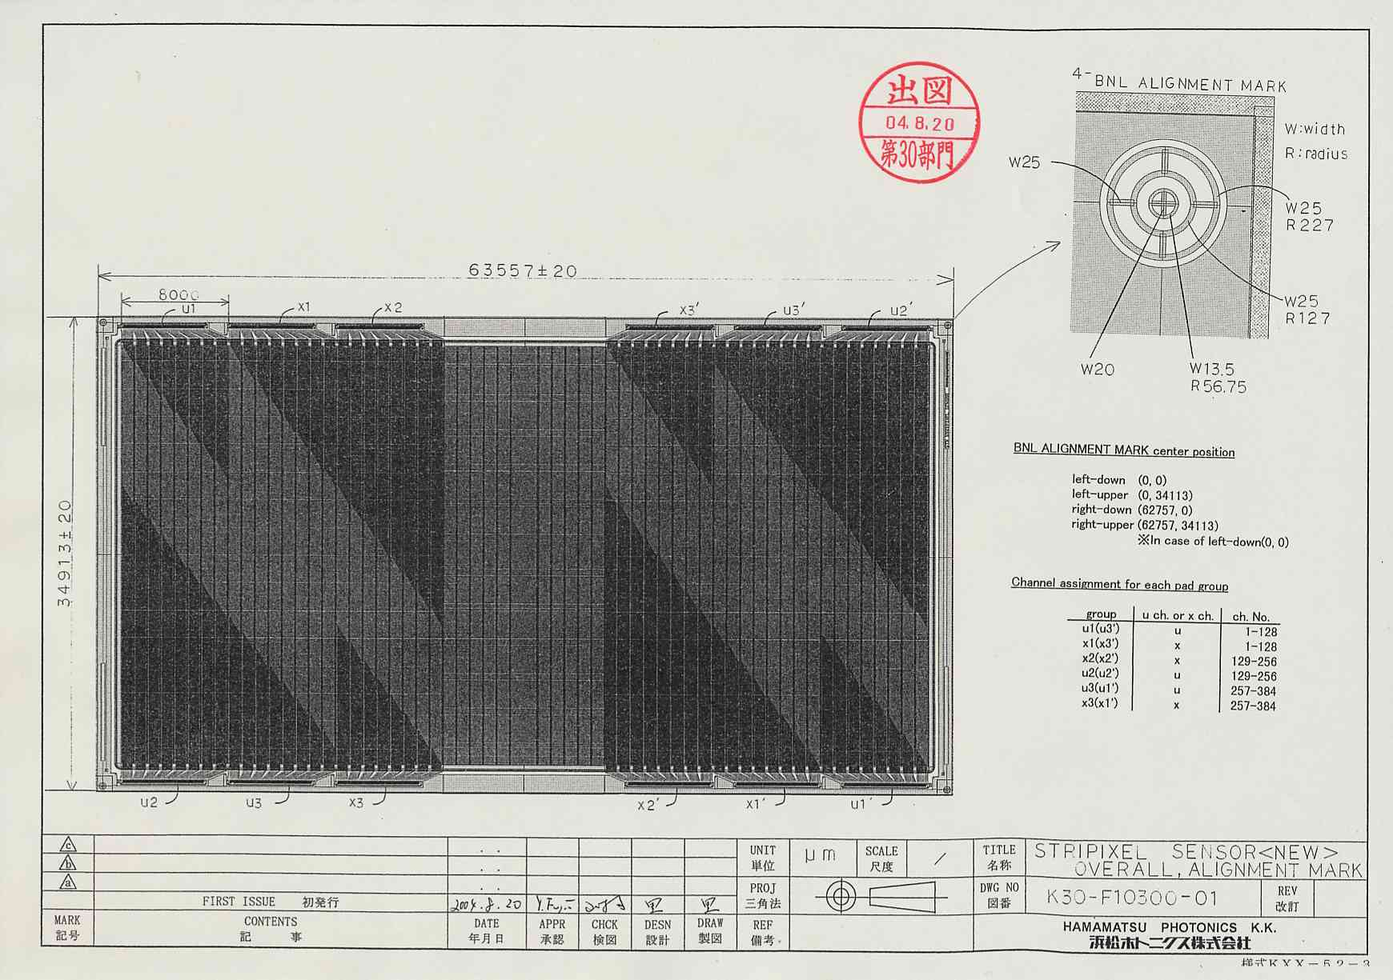
Figure 2.1

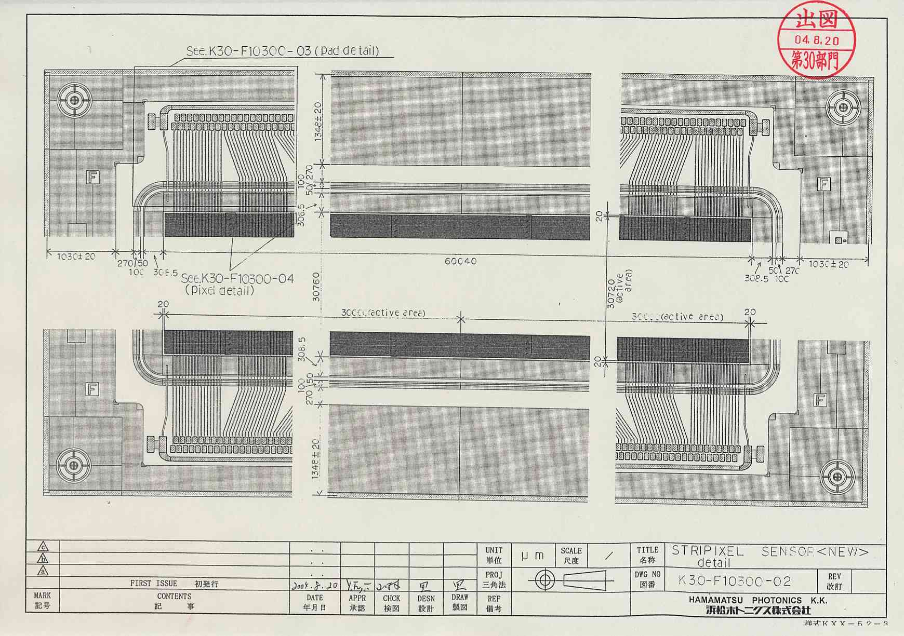
Figure 2.2
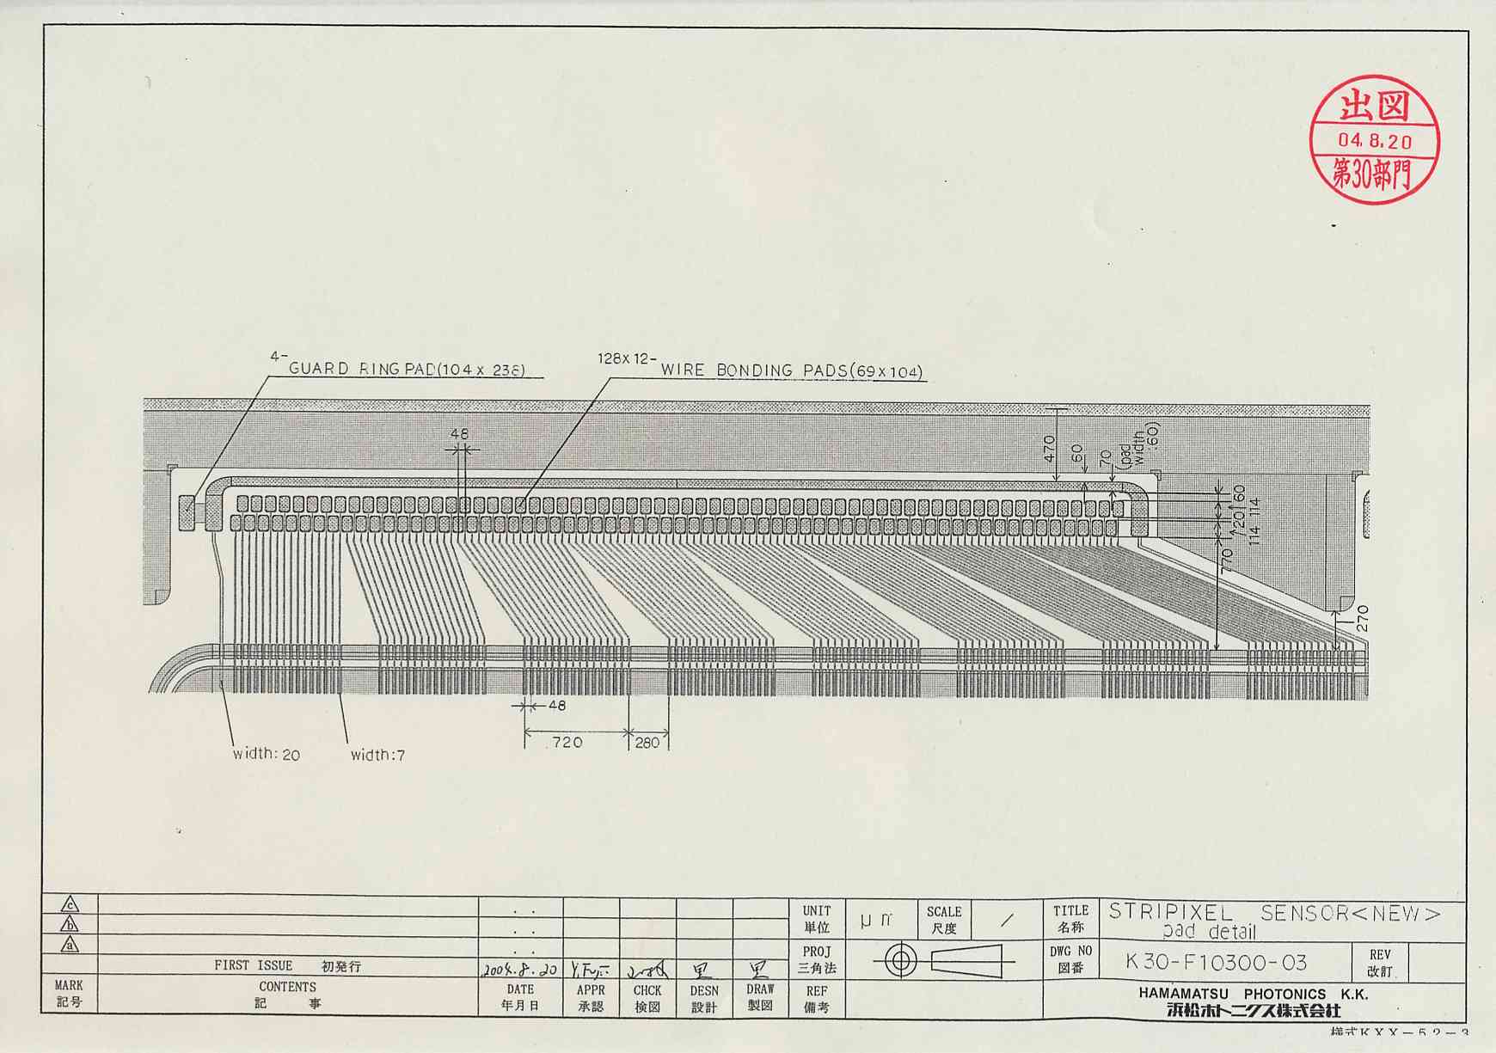
Figure 2.3

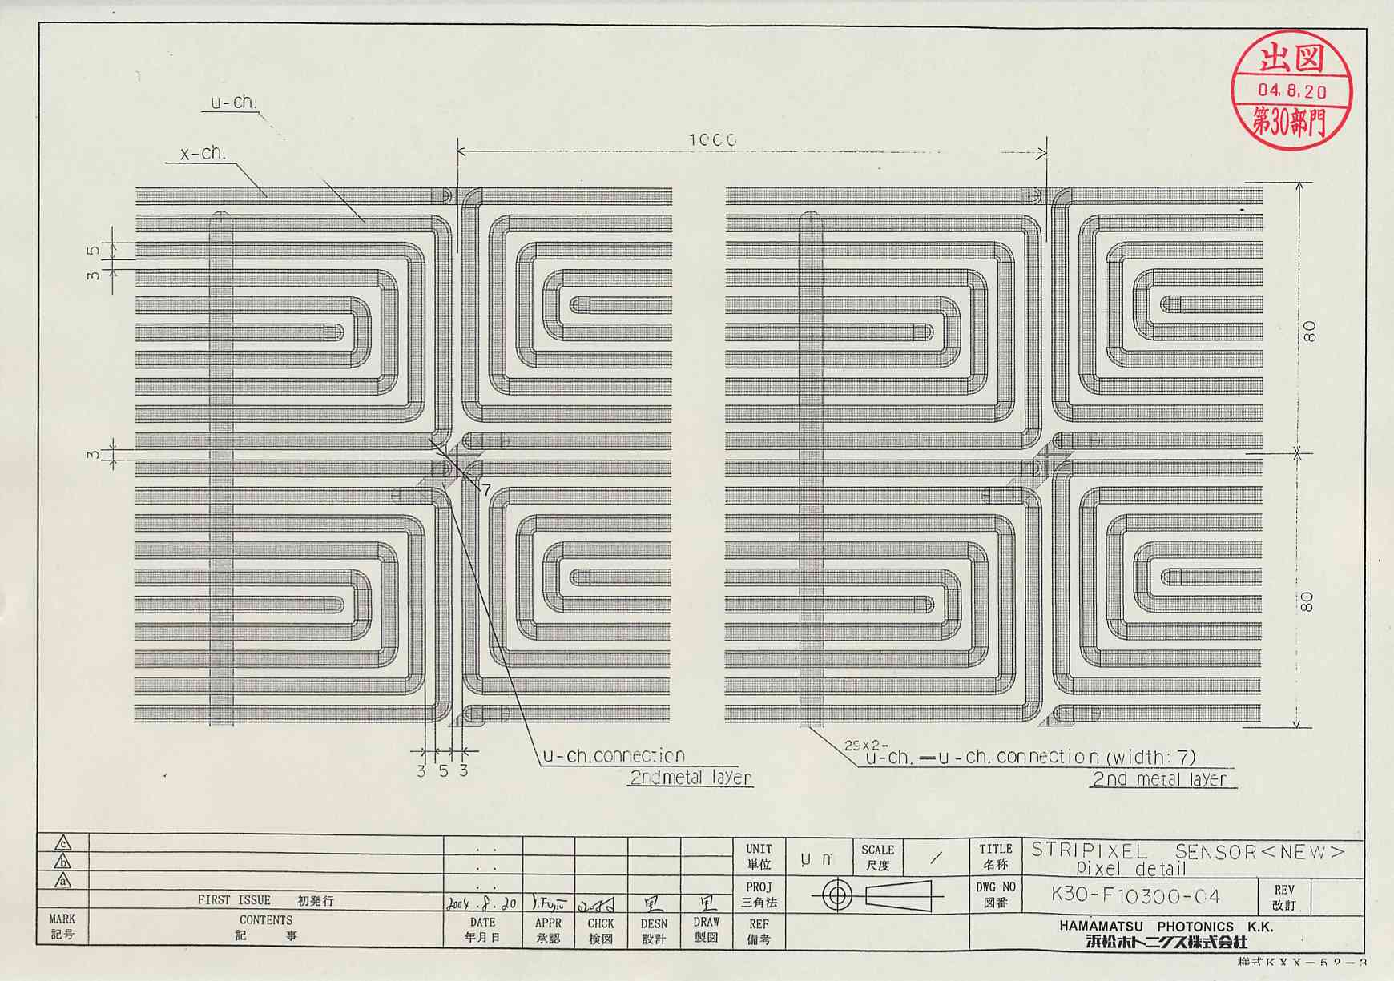
Figure 2.4
3. PISA geometry

Table 3.1 PISA geometry
 | 1st layer | 2nd layer | 3rd layer | 4th layer
Radius [cm] ^{*1} | 2.5 | 5.0 | 10.0 | 14.0
Number of sensors per ladder | 4 | 4 | 5 | 6
Sensor size [μm²] (z×φ) | 56,720 × 13,920 |  | 63,557 × 34,913
Sensor thickness [μm] (X₀ %) | 200 (0.21) |  | 625 (0.67)
Sensor gap in z-direction | 0 | 0 | 0 | 0
Passive material thickness [X₀ %] ^{*2} | 1.0 |  | 1.5
Number of ladders | 10 | 20 | 18 | 26
φ acceptance per sensor [deg] ^{*1} | 28.495 | 14.484 | 17.332 | 12.432
Sensor tilt angle [deg] ^{*1} | 7.8 | 7.0 | 7.3 | 7.0
*1 : Definition is given in Figure 3.8.
*2 : Numbers are taken from the VTX proposal (July 2004).
Table 3.2 Barrel VTX parameters in PISA

$sili_br_par
sili_br_nlayers = 4,
sili_br_r = 2.5, 5.0, 10.0, 14.0,
sili_br_z = 0.0, 0.0, 0.0, 0.0,
sili_br_nsn = 4, 4, 5, 6,
sili_br_snhalfx = 0.696, 0.696, 1.74565, 1.74565,
sili_br_snhalfy = 0.01, 0.01, 0.03125, 0.03125,
sili_br_snhalfz = 2.836, 2.836, 3.17785, 3.17785,
sili_br_x0add = 0.01, 0.01, 0.015, 0.015,
sili_br_snzgap = 0., 0., 0., 0.,
sili_br_nsec = 2, 2, 2, 2,
sili_br_nlad(1,1) = 5, 5,
sili_br_nlad(1,2) = 10, 10,
sili_br_nlad(1,3) = 9, 9,
sili_br_nlad(1,4) = 13, 13,
sili_br_phic(1,1) = 0., 180.,
sili_br_phic(1,2) = 0., 180.,
sili_br_phic(1,3) = 0., 180.,
sili_br_phic(1,4) = 0., 180.,
sili_br_dphi = 28.495, 14.484, 17.332, 12.432,
sili_br_tilt = 7.8, 7.0, 7.3, 7.0,
sili_br_nspring = 8,
sili_br_spz = -11.8, -11.8, -16.5, -19.8, 11.8, 11.8, 16.5, 19.8,
sili_br_sprin = 2.9, 5.4, 10.7, 14.7, 2.9, 5.4, 10.7, 14.7,
sili_br_sprout = 3.4, 5.9, 11.2, 15.2, 3.4, 5.9, 11.2, 15.2,
sili_br_spthck = 0.25, 0.25, 0.25, 0.25, 0.25, 0.25, 0.25, 0.25,
$end
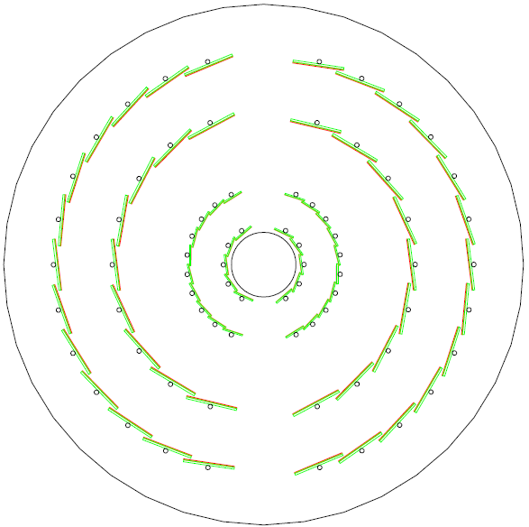

Figure 3.1 Beam’s view in PISA output.

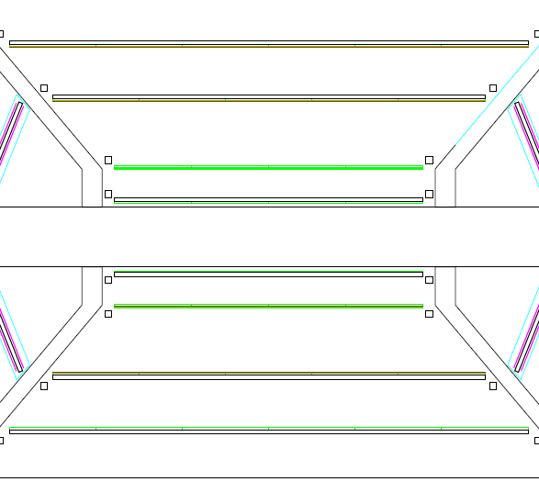
Figure 3.2 Cut view at y=0 in PISA output.
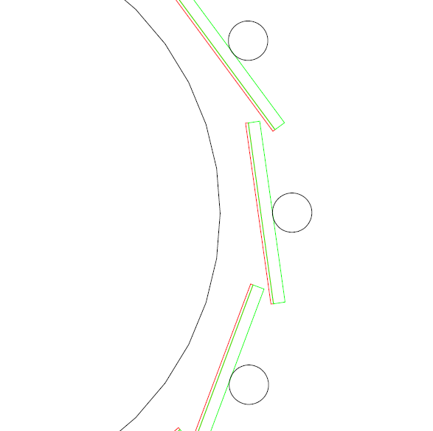

Figure 3.3 1st layer in PISA output (See Figure 3.8 for dimension.).

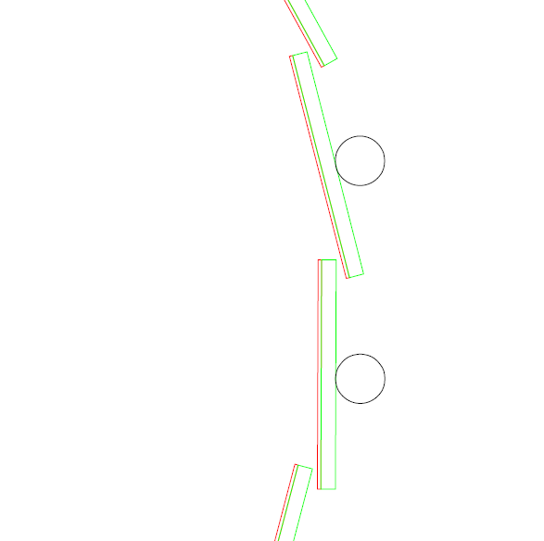

Figure 3.4 2nd layer in PISA output (See Figure 3.8 for dimension).

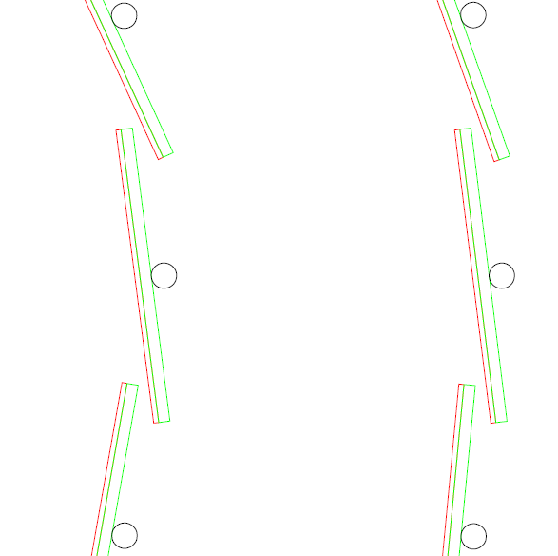

Figure 3.5 3rd and 4th layer in PISA output (See Figure 3.8 for dimention).

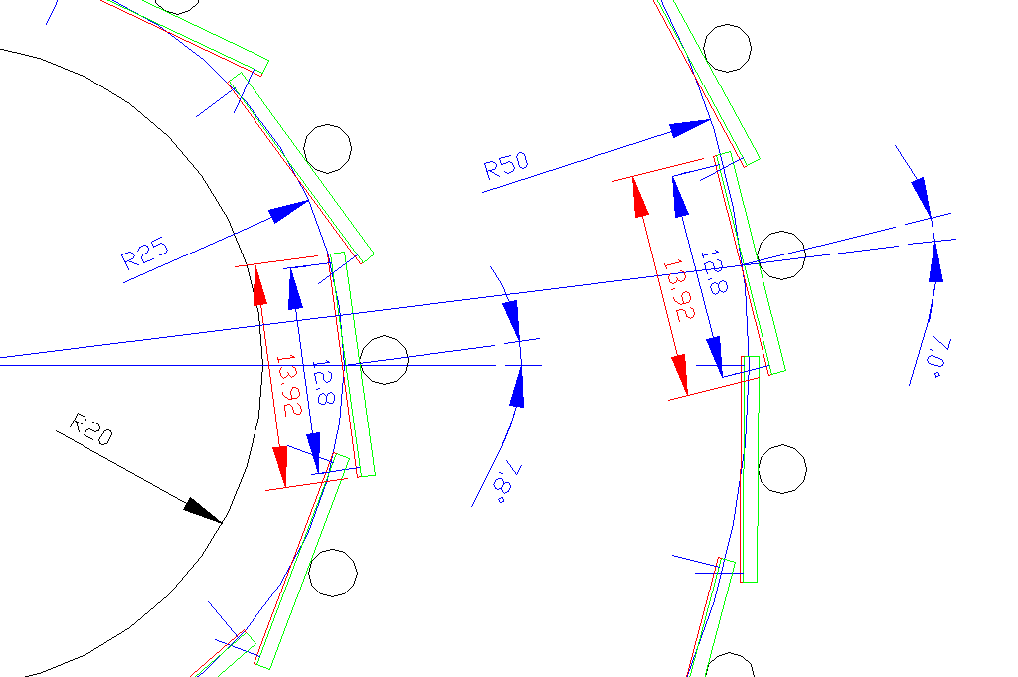

Figure 3.6 Dimension in 1st and 2nd layers.

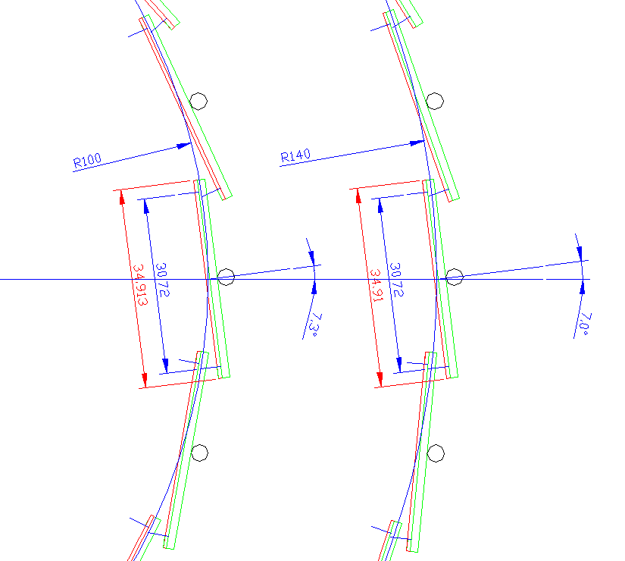

Figure 3.7 Dimension in 3rd and 4th layers.

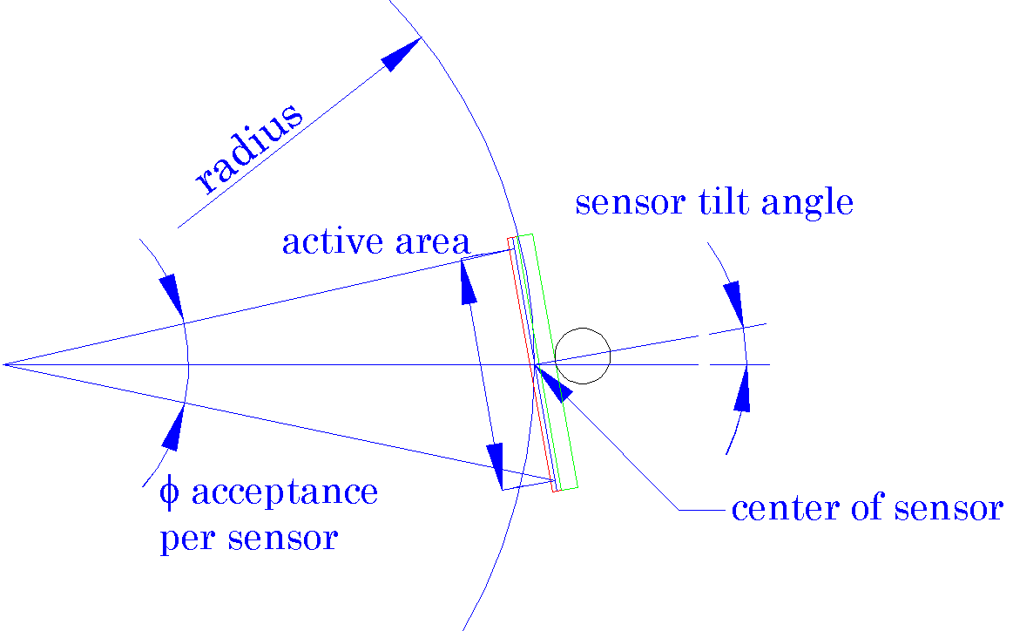

Figure 3.8 Definition of radius, φ acceptance per sensor and sensor tilt angle.

